**NATIONAL UNIVERSITY OF SCIENCE AND TECHNOLOGY**



**FACULTY OF INDUSTRIAL TECHNOLOGY**

**DEPARTMENT OF INDUSTRIAL AND MANUFACTURING**

**ENGINEERING**

**FINAL YEAR PROJECT [TIE5009]**

**For**

**TINASHE TANYARADZWA MABIKA (N01519975J)**

**SOIL MOISTURE PREDICTION FOR SMART IRRIGATION SCHEDULING**

**SUPERVISOR:**

# 

# DECLARATION

I, **TINASHE TANYARADZWA MABIKA** declare that:

The research reported in this dissertation, except where otherwise stated, is my original work.

This dissertation has not been submitted for examination for any degree at this or any other university.

This dissertation does not contain other persons’ writing, data, pictures or graphs except where acknowledged as having been sourced from the other persons. Where written sources have been used:

The words have been paraphrased and the information attributed to the source through referencing;

With exact words quoted, the writing has been placed in quotation marks and referenced.

**DECLARATION OF COPYRIGHT**

I hereby do not grant permission to the National University of Science and Technology Library to reproduce copies of this dissertation or to lend or sell such copies for private, scholarly or scientific research purposes.

I reserve other publication rights. No extensive extracts from this dissertation may be printed in any form or otherwise reproduced without my written permission.

**SIGNATURE: …………………………………**

**PERMANENT ADDRESS: 5289 Nkwisi Gardens, Tynwald, Westlea, Harare**

**DATE: ..............................................................**

# DEDICATIONS

# ACKNOWLEDGEMENTS

# ABSTRACT

Water balance is essential for high quality yields. Under-wateredcrops suffer from nutrient deficiencies while over-watered plants are more prone to diseases and can lead to root death through choking. Also, over-watered plantsare not able to withstand dry spells during dry seasons. Water-saving agricultural practices and sound watermanagement strategies are therefore required to ensureviability of the farming industry.

With great advancements in Internet of Things and Artificial Intelligence its high time we leverage the beauty of these technologies in Zimbabwe as it answers to most of the challenges we are facing. Reduction in production costs through automation of manual tasks, remote monitoring, high output yields and better land fertility are some of the advantages of applying these technologies into farming.

This study is aimed at developing a smartirrigation controller which is able acquire real-time soil moisture contents, temperature, humidity, volume of water used and sunshine intensity, and stores to an online database. Server-side script fetches the data from the database and feed to a dynamic artificial neural network (DANN) which responds with a prediction of soil moisture for the next time step to the controller and decisions can be made to best optimize amount of water to be irrigated and timing. The controller is able to send SMS to the farm operators. This data is also relayed to aweb application where it can provide valuable information to any operator concerned and can remotely control the irrigation processes.

The heart of the controller circuit isthe WeMos Atmega2560 Wi-Fi based micro-controller that uses C++ as a high-level programming language. Message notifications are achieved by interfacing with sim800L GSM module. The dynamic neural network is a deep learning Long Short-Term Memory made from TensorFlow.js.

# Table of Contents

DECLARATION i

DEDICATIONS iii

ACKNOWLEDGEMENTS iv

ABSTRACT v

Table of Contents vi

LIST OF FIGURES x

LIST OF TABLES xi

1 CHAPTER ONE - INTRODUCTORY CHAPTER 1

1.0 Introduction 1

1.0 Background 1

1.1 Aim 3

1.2 Objectives 3

1.3 Scope 4

1.4 Justification 4

1.5 Methodology 5

1.6 Timeline 7

1.7 Summary 8

2 CHAPTER TWO – LITERATURE REVIEW 9

2.0 Introduction 9

2.1 Types of Agricultural Water Use 9

2.1.1 Irrigation 9

2.1.2 Rain-fed Farming 17

2.2 Specific Plant Water Requirements 17

2.2.1 Soil Moisture for Optimal Crop Growth 17

2.2.2 Seasonal Crop Water Needs 20

2.2.3 Drought sensitivity 20

2.2.4 Importance of Water to Plants 21

2.3 Control Systems 21

2.3.1 Types of Control Systems 22

2.4 Cloud Services 23

2.4.1 Types of Cloud Services: 23

2.4.2 Cloud Services Providers 24

2.5 Data Forecasting 25

2.5.1 Types of Forecasting Methods 25

2.5.2 Neural Networks 27

2.6 Hardware 31

2.6.1 Micro-controllers and Processors 31

2.6.2 Communication 37

2.6.3 Data Storage 40

2.6.4 Sensors 41

2.6.5 Displays 51

3 CHAPTER THREE: DESIGN CONCEPTION 54

3.0 Introduction 54

3.1 Concept Generation 54

3.1.1 Determination of Customer Requirements 55

3.2 Generation of Concepts 56

3.2.1 Concept A 56

3.2.2 Concept B 59

3.2.3 Concept C 62

3.2.4 Concept D 64

3.3 Concept Selection 65

3.3.1 Concept Screening 66

3.3.2 Concept Scoring 67

3.4 Selection of Forecasting Model 68

3.4.1 Long Short-Term Memory 69

3.5 Proposed System 70

3.5.1 Principle of operation 70

3.5.2 Predictive Scheduling Block Diagram 71

3.5.3 Program Flow-chart 72

3.6 Summary 73

4 CHAPTER FOUR: DETAILED DESIGN 74

4.0 Introduction 74

4.1 Control System 74

4.1.1 Introduction 75

4.1.2 Development of Microcontroller Program 75

4.1.3 Soil Moisture Calibration 79

4.2 Hardware Controller Design 80

4.2.1 Overview of the system 80

4.2.2 Power supply design 80

4.2.3 Selection of Sensors 83

4.3 Web Application Design 86

4.4 Prediction Model 86

4.5 Summary 93

REFERENCES 95

# LIST OF FIGURES

Figure 1.1 Poor yield due to under irrigation (krcu.org, 2013) 2

Figure 1.2 Picture showing over irrigated land (Columbia.edu, 2005) 3

Figure 1.3 The Design and Development model. 6

Figure 1.4 Timeline 7

Figure 2.1 Flood Irrigation () 10

Figure 2.2 Drip Irrigation () 11

Figure 2.3 Sprinkler irrigation() 12

Figure 2.4 Centre Pivot () 13

Figure 2.5 Sub-Surface Irrigation() 14

Figure 2.6 Manual irrigation () 15

Figure 2.7 Soil Water Holding Capacity () 19

Figure 2.8 Open Loop Control System() 22

Figure 2.9 Closed Loop System 23

Figure 2.10 Qualitative Forecasting Methods 25

Figure 2.11 Quantitative Forecasting Methods 26

Figure 2.12 Neural Network () 28

Figure 2.13 Feed Forward Neural Network 29

Figure 2.14 Recurrent Neural Network 30

Figure 2.15 Long Short – Term Memory () 31

Figure 2.16 8051 Microcontroller () 32

Figure 2.17 PIC Microcontroller() 33

Figure 2.18 Atmel AVR Microcontroller () 34

Figure 2.19 Arduino Uno() 35

Figure 2.20 Arduino Mega2560() 36

Figure 2.21 Arduino lilypad() 37

Figure 2.22 Sim800L GSM Module() 38

Figure 2.23 Sim800L GSM Module () 38

Figure 2.24 ESP8266 Wi-Fi Module 39

Figure 2.25 SD Card Data Logger() 41

Figure 2.26 Capacitive Soil Moisture Sensor() 42

Figure 2.27 Time Domain Reflectometry Sensor() 43

Figure 2.28 Resistive Moisture Sensor () 44

Figure 2.29 Thermocouple Sensor () 46

Figure 2.30 Resistor Temperature Detector() 46

Figure 2.31 Thermometer () 47

Figure 2.32 LM35 Sensor () 48

Figure 2.33 IR sensor() 49

Figure 2.34 DHT22 Sensor () 50

Figure 2.35 20-x-4 LCD () 52

Figure 3.1 Concept A Block Diagram 56

Figure 3.2 Concept A Flow Chart 57

Figure 3.3 Concept B Block Diagram 59

Figure 3.4 Concept B Flow Chart 60

Figure 3.5 Concept C Block Diagram 62

Figure 3.6 Concept C Flow Chart 63

Figure 3.7 Concept D Block Diagram 64

Figure 3.8 Long Short-Term Memory Cell 69

Figure 3.9 Proposed System Block Diagram 70

Figure 3.10 Proposed System Block Diagram 71

Figure 3.11 Proposed System Flow System 72

# LIST OF TABLES

Table 1.1.1 Scheduled timeline **Error! Bookmark not defined.**

Table 2.1 Crop water need 20

# CHAPTER ONE - INTRODUCTORY CHAPTER

## Introduction

World climate change is causing a major blow on global water supplies. 70% of world’s fresh water is used for irrigation purposes, it is therefore important to develop and leverage trending technologies to monitor and control agricultural fields for sustainable and efficient water use (Victor et al., 2009). Irrigation should meet specific plant water demands to avoid overand under irrigation. This can be attained by performing irrigation operations basing on time, forecast and present soil moisture contents. Precision irrigation aims to find and quantify plant water needs in a smart way (Smith, 2011). This field of study is very helpful in estimating farming parameters like fertilizers and other input needsby assessing soil conditions, thus preventing inflexiblepractices in farming. The irrigation amount and timing are based on measurementsof soil, plant, and climatic variables from which the plant water need is inferred. Precisionirrigation and artificial intelligence applications have shown to improve water use efficiency, reduce energy consumption, and enhancecrop productivity by leveraging advances in control systems, and optimization algorithms.

## Background

With the drive to rebuild and grow our economy, it is now imperative that we utilize our abundant resources on the agricultural front. Agriculture occupies a central space in the Zimbabwean economy and has the potential to significantly reduce poverty, enhance economic growth and with time entrench economic stability.

According to the Food and Agriculture Organization, 70% of Zimbabwe’spopulation depends on agriculture. Climate change is threateningagriculture productivity and making worse some of Zimbabwe’s key agriculture challenges which arelow soil fertility and reliance on rain fed systems. In 2012, 76% of rural households lived below the poverty datum line and 32%of children under five were stunted as a result of malnutrition

The continuous increase in food demand requires a rapid improvement in food productiontechnologies. Food insecurity is a major challenge in developing countries. In a country likeZimbabwe where the economy is mainly agriculture based, use of technology to improve on yields isparamount.

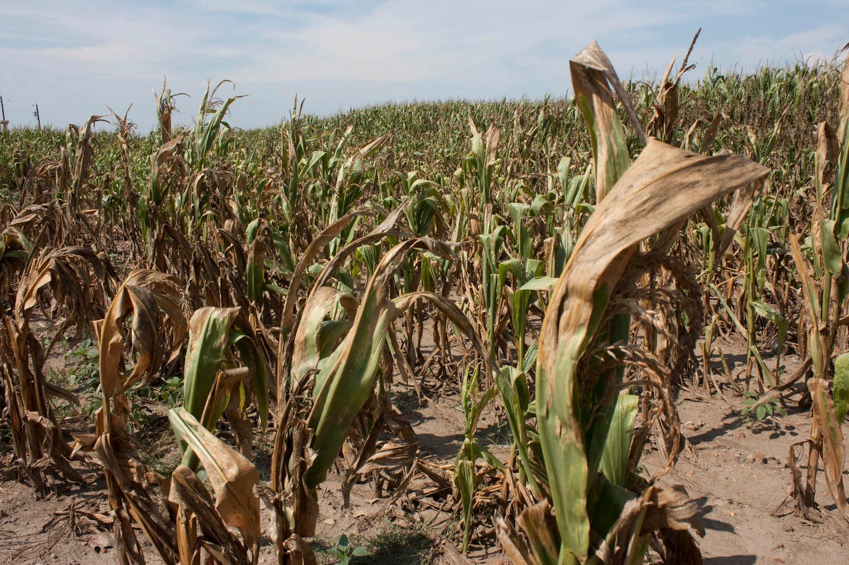

Figure 1.1 Poor yield due to under irrigation (krcu.org, 2013)

Most ofirrigation controllers that are locally available are ON/OFFtype and these cannot give optimal results inirrigation costs and crop yield.

Picture below shows a major problem of over irrigation experienced by traditional open loop irrigation systems. Water is wasted, crops become more vulnerable to water borne diseases, land fertility decreases as vital minerals are washed away with excess water and as a result poor yields are experienced.

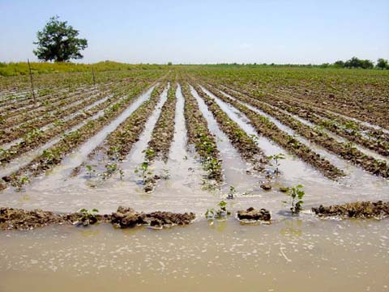

Figure 1.2 Picture showing over irrigated land (Columbia.edu, 2005)

## Aim

To develop a smart irrigation system that is able to predict soil moisture contents to optimize irrigation schedules.

## Objectives

* Design an irrigation controller based on AVR micro-controller.
* Design Web application for remote monitoring.
* Do experiments to calibrate Soil Moisture Sensor.
* Create a Neural Network Model to predict soil moisture contents.

## Scope

The scope of this project entails the design and implementation of a micro-controller-based irrigationsystem driven by an artificial neural network to help on irrigation scheduling. Also, the design of a notification interface which will be sending important data about the field to the farmer via SMS’s. An online dashboard is also going to be made using existing frameworks for monitoring and controlling irrigation processes. A high-level Deep Learning toolbox (TensorFlow.js) is going to be used to model the Long Short-Term Memory network for time series prediction.

## Justification

The proposed project will help the country as a whole as it is a step towards minimizing water supply wastages through run-off and evaporation of excess water as a result of over irrigation. Every farmer in Zimbabwe has a goal of producing healthy crops and high yields and this can be achieved by introducing smart technologies which makes use of big data and learning strategies to assist in farming (Baiphethi and Jacobs, 2009). By doing so, Zimbabwe will gain back its fame in food security. This will reduce manual work of controlling the system, thereby reducing production costs, it is with no doubt that this technology will be of great help to farmers as it requires few operators in the field to monitor and control

Irrigation is one of the most reliable method of crops production.More land now is being under irrigation and there is a need for optimal use of water. With the great advancement in electronics, microcontrollers and microprocessors has been used together with various sensors to gather data and control physicalquantities like temperature, humidity, heat and light. Using these technologies automation of processes is greatly increasing. Irrigation systems in crop production can also be automated. The systems help in saving water and thus more land can bebrought under irrigation. Crops grown under controlled conditions tend to be healthier and thusgive more yields.

Every farmer wants to know what’s happening to the crops so that good decision can be made in time. This project makes it possible for remote monitoring of soil moisture, outdoor humidity and temperature, volume of water usage.

## Methodology

To achieve the project research techniques and tools are going to be used in the development phase. Secondary information to be used in the review will be developed from mainly journals,  
internet, hand books, eBooks and books. In building the controller, software api’s and hardware documentations are going to be reviewed.

Methods to be used:

* Data Gathering to obtain training data for soil moisture predictive model
* Concept selection through scoring of possible solutions.
* Developing an Artificial Neural Network in TensorFlow.js to create soil moisture content forecasts
* Developing cloud server controllers to interface backend services.
* Programming WeMos atmega2560 micro-controller for hardware controlling system.
* Building a prototype.

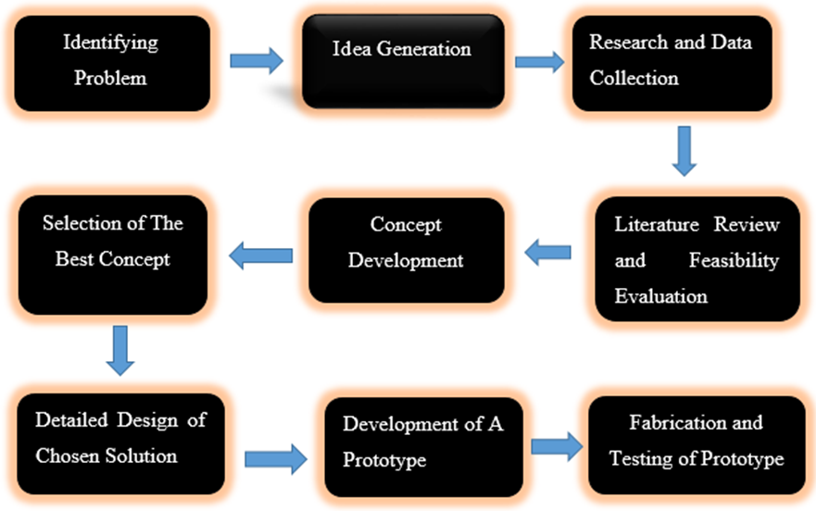

Figure 1.3 The Design and Development model.

## Timeline

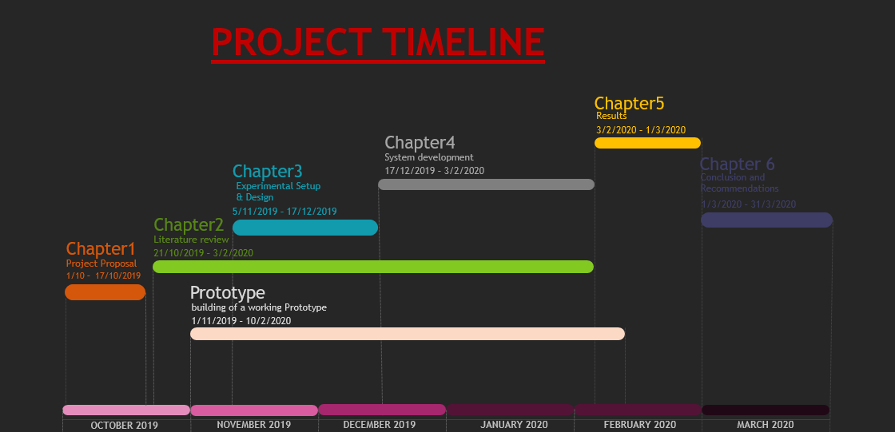

Figure 1.4 Timeline

Table 1.1 Timeline

|  |  |  |  |
| --- | --- | --- | --- |
| MILESTONE | START DATE | END DATE | NOTES |
| Chapter 1 | 1-10-2019 | 17-10-2019 | Project Proposal – Introduction to the project |
| Chapter 2 | 21-10-2019 | 3-2-2020 | Literature Review |
| Chapter 3 | 5-11-2019 | 17-12-2019 | Design and setup |
| Chapter 4 | 17-12-2019 | 3-2-2020 | System Development – detailed design of the concept and flow process |
| Chapter 5 | 3-2-2020 | 1-3-2020 | Project Results – Presentation of the system output |
| Chapter 6 | 1-3-2020 | 31-3-2020 | Conclusion and Recommendation |
| Prototype | 1-11-2019 | 10-2-2020 | Procure hardware components, build the controller and programming |

## Summary

The proposed project intends to use Artificial Intelligent techniques, which are growing in the field of agriculture and engineering as a whole. By gathering soil moisture values the system will be used to generate irrigation schedules and predict on the soil moisture values for the upcoming days and decisions can be made in time. In doing so, the system will encourage maximum efficiency of water usage and plant growth and healthy. With its capabilities, it will wrestle with problems related with under and over irrigation and major decisions will be made in time.

# CHAPTER TWO – LITERATURE REVIEW

## Introduction

## Types of Agricultural Water Use

There are two main ways that farmers and ranchers use agricultural water to cultivate crops

### Irrigation

Irrigation is the process of applying water to the crops artificially to fulfil their water requirements. Nutrients may also be applied to the crops through irrigation. The various sources of water for irrigation are wells, ponds, lakes, canals, tube-wells, and even dams. Irrigation offers moisture required for growth and development, germination, and other related functions.

Water moistens the soil and thus helps in penetration of roots even into the dry field. The frequency, rate, amount and time of irrigation are different for different crops and also vary according to the types of soil and seasons. For example, summer crops require a higher rate of water as compared to winter crops.

#### Types of Irrigation

There are different types of irrigation practised for improving crop yield. These types of irrigation systems are practised based on the different types of soils, climates, crops and resources. The main types of irrigation followed by farmers include:

##### Surface Irrigation

Water is applied and distributed over the soil surface by gravity. It is by far the most common form of irrigation throughout the world and has been practiced in many areas virtually unchanged for thousands of years (Awati and Patil, 2012). Surface irrigation is often referred to as flood irrigation, implying that the water distribution is uncontrolled and therefore, inherently inefficient. In reality, some of the irrigation practices grouped under this name involve a significant degree of management (for example surge irrigation) (Heath, 1998). Surface irrigation comes in three major types; level basin, furrow and border strip.

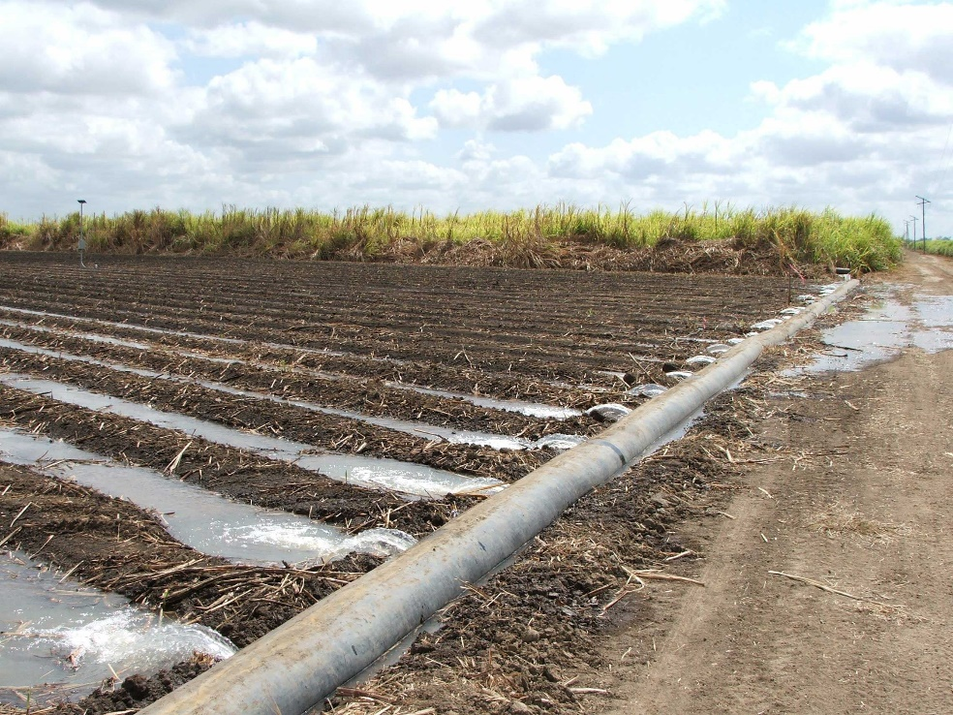

Figure 2.1 Flood Irrigation

##### Localized irrigation

Localized irrigation is a method of applying water that results in wetting only a small area of the soil surface and sometimes only part of the root zone. Water is applied near the base of the plant so that the application is concentrated in the root zone (Mmolawa, 2000). Water is generally applied at a low flow rate, in small amounts, and frequently. The application devices may be small tubes, orifices, nozzles, or perforated pipes. The water may either be applied above or below the soil surface (Christiansen, 2001). The main components of a localized irrigation system are the water supply (including flow and pressure regulators), the filtration system, main lines, sub-main lines, laterals, and distributors.

The primary advantages of localized irrigation systems are the high efficiency rates that can be achieved, sometimes as high as 90%. High efficiency may result in very significant water savings. Often a localized irrigation system will allow a farmer to irrigate twice the area possible with surface irrigation. Precise control of water and nutrient application often results in much higher yields and quality (Evans, Wu. and Smajstrala., 2007.). Control of weeds and pests may be better as the entire soil surface is not wetted nor is the foliage. A localized irrigation system may allow the use of more saline water, and can be used effectively with low infiltration soils that cannot be sprinkler irrigated. Some disadvantages are the higher initial costs of the systems, salinity build-ups, more limited root development, and higher technology requirements. Later savings may be offset by higher maintenance costs (Clark, 2008). There are low cost methods, however, for irrigating garden sized plots with localized irrigation.

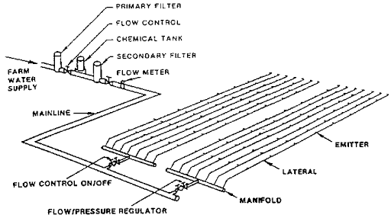

Figure 2.2 Drip Irrigation

##### Sprinkler irrigation

Sprinkler irrigation is a method of applying irrigation water which is similar to natural rainfall. Water is distributed through a system of pipes usually by pumping (Pair, 1970). It is then sprayed into the air through sprinklers so that it breaks up into small water drops which fall to the ground. The pump supply system, sprinklers and operating conditions must be designed to enable a uniform application of water.

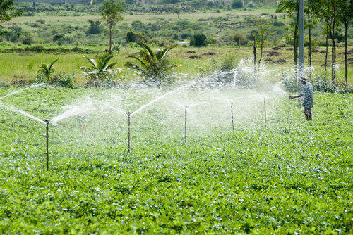

Figure 2.3 Sprinkler irrigation

##### Centre Pivot Irrigation

The centre pivot (CP) is a low/medium pressure fully mechanized automated irrigation system of permanent assemble. The centre pivot system consists of one single sprayer or sprinkler pipeline of relatively large diameter, composed of high tensile galvanized light steel or aluminium pipes supported above ground by towers move on wheels, long spans, steel trusses and/or cables (Babiker, 2019). One end of the line is connected to a pivot mechanism at the centre of the command area; the entire line rotates about the pivot. The application rate of the water emitters varies from lower values near the pivot to higher ones towards the outer end by the use of small and large nozzles along the line accordingly

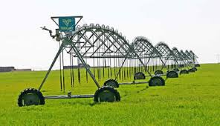

Figure 2.4 Centre Pivot

##### Sub-irrigation

It is a method of irrigation where water is delivered to the plant root zone. The excess may be collected for reuse. Sub irrigation is used in growing field crops such as tomatoes, peppers, and sugar cane in areas with high water tables such as Florida and in commercial greenhouse operations (Fipps, 2003).

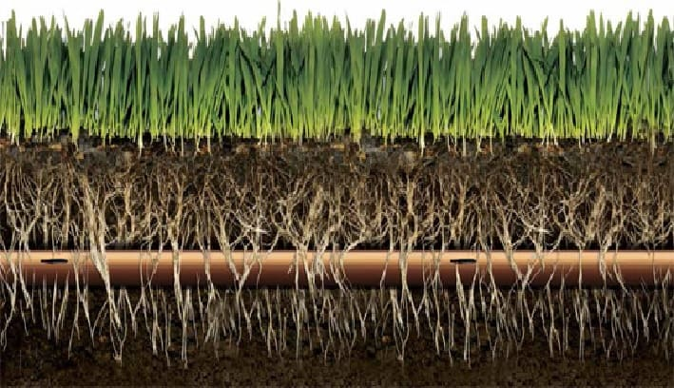

Figure 2.5 Sub-Surface Irrigation

##### Manual Irrigation

Manual irrigation systems are very simple, labour intensive, but effective methods for making water available to crops. Manual irrigation systems are easy to handle and there is no need for technical equipment. It is important that they are constructed correctly to avoid water loss and crop shortfall. The systems allow for high self-help compatibility and have low initial capital costs (Burns, 1993).

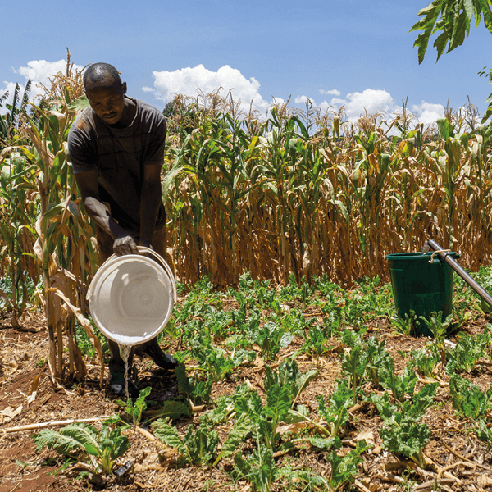

Figure 2.6 Manual irrigation

#### Methods of Irrigation

Irrigation can be carried out by two different methods:

* Traditional Methods
* Modern Methods

##### Traditional Methods of Irrigation

In this method, irrigation is done manually. Here, a farmer pulls out water from wells or canals by himself or using cattle and carries to farming fields. This method can vary in different regions. The main advantage of this method is that it is cheap. But its efficiency is poor because of the uneven distribution of water. Also, the chances of water loss are very high. Some examples of traditional system are pulley system, lever system, chain pump and dhekli. Among these, the pump system is the most common and used widely (Roy et al, 1982).

##### Modern Methods of Irrigation

The modern method compensates the disadvantages of traditional methods and thus helps in the proper way of water usage.

The modern method involves two systems:

* Sprinkler system
* Drip system

#### Irrigation Scheduling

#### Importance of Irrigation

According to Arnold, Troost, and Berger., 2015

* Agriculture is often greatly hampered due to irregular, insufficient or uncertain rain. Proper irrigation systems can secure uninterrupted agriculture.
* The productivity of irrigated land is more than the un-irrigated land. Crop yields everywhere in the developing world are consistently higher in irrigated areas than in rainfed areas1.
* Seeds cannot grow in dry soil as moisture is necessary for the germination of seeds. With the help of irrigation supply, the required moisture content of soil for the growth of seed can be ensured.
* Multiple cropping in a year is possible through irrigation. This will enhance production & productivity. In many areas of India, two or three crops in a year are cultivated with irrigation facilities.
* Through the irrigation, it is possible to supply the required amount of hydrogen & oxygen, which is important for the proper development of plant root.
* A plant can absorb mineral nutrients from the irrigated soil. Thus, irrigation is essential for the general growth of the plant.
* Bringing more land under cultivation is possible through irrigation.
* Insufficient rain may also cause drought & famines. Irrigation can play a protective role during the period of drought & famines.
* Irrigation contributes to the economic growth and poverty reduction. As income and employment are closely related to output and irrigation increases production, substantial increase in income is achieved in the countryside.

### Rain-fed Farming

Rain-fed farming is the natural application of water to the soil through direct rainfall. Relying on rainfall is less likely to result in contamination of food products but is open to water shortages when rainfall is reduced. On the other hand, artificial applications of water increase the risk of contamination (Laraus, 2004).

## Specific Plant Water Requirements

### Soil Moisture for Optimal Crop Growth

Soil moisture and its availability to support plant growth is a primary factor in farm productivity. Too little moisture can result in yield loss and plant death. Too much causes root disease and wasted water. Just as important, water is a delivery mechanism for any nutrients that are not tightly bound to the soil. Whether these nutrients are delivered to the field through the irrigation system or through other means, movement of water within the soil governs how they are delivered to the plant roots. Good water management is important within itself, but good water management also means good nutrient management. Precise control over the root zone environment, in terms of both water and nutrient content, leads to healthier crops and higher yields (Bot and Benites., 2005).

#### Water Holding Capacity

Water resides in the spaces between soil particles. The force of gravity constantly acts on water in the soil to move it downward and out of reach of plants. The counterbalancing force which keeps it from moving downward is surface tension, which causes the water to 'stick' to soil particles. The smaller the soil particles are, the more combined surface area they have, and the more they are able to hold onto water through its surface tension. Therefore, the ability of water to move through soil and be stored in soil depends heavily on soil type (Hillel, 2003).

When water enters a soil with large sandy particles, only a small amount stays attached to the particles, and the remainder quickly drains downward. Sand has low 'water holding capacity.' Conversely, a volume of clay soil has huge numbers of small particles with large surface area. When water enters a clay soil, surface tension holds it tightly to the soil particles and only a small remainder drain downward. A soil with a high-water holding capacity can store large amounts of water relative to its own volume after a rain event and, under the right conditions, this stored water can remain available for plants to use (Bell, 2013).

In a soil with very small particles, the same surface tension forces that allow for a large water holding capacity also make it difficult for plants to extract and use the water. Water does not move easily through a fine-particle soil and requires a large amount of energy for plants to extract and use it. The force a plant must exert on water to separate it from soil particles and move it into the root system is referred to as 'tension'. In most on-farm applications tension is measured in centibars (1/100 bar) as a negative pressure or vacuum (plants 'suck' the water out of the soil to use it).

The interaction between soil type, water holding capacity and water availability is illustrated in the Soil Texture Triangle shown in below Figure.

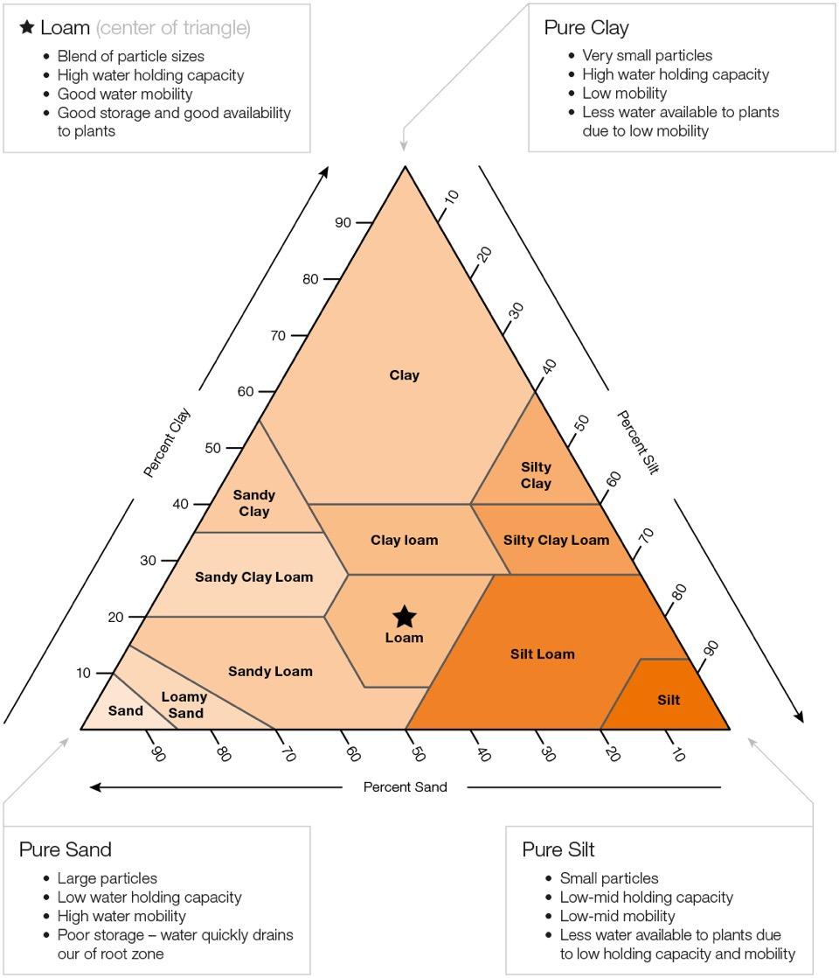

Figure 2.7 Soil Water Holding Capacity

### Seasonal Crop Water Needs

Table 2.1 Crop water needs

|  |  |  |
| --- | --- | --- |
| **Crop** | **Crop water need (mm/total growing period)** | **Total growing period (days)** |
| Beans | 300 - 500 | 70-95 |
| Citrus | 900 - 1200 | 240-365 |
| Cotton | 700 - 1300 | 190-195 |
| Groundnut | 500 - 700 | 90-100 |
| Maize | 500 - 800 | 95-120 |
| Sorghum/millet | 450 - 650 | 120-130 |
| Soya bean | 450 - 700 | 135-150 |
| Sunflower | 600 - 1000 | 125-130 |
|  |  |  |

There is a large variation of values not only between crops, but also within one crop type. In general, it can be assumed that the growing period for a certain crop is longer when the climate is cool and shorter when the climate is warm.

### Drought sensitivity

Crops differ in their response to moisture deficit. This characteristic is commonly termed "drought resistance". When crop water requirements are not met, crops with a high drought sensitivity suffer greater reductions in yields than crops with a low sensitivity.

Table 2.2 drought sensitivity

|  |  |  |
| --- | --- | --- |
| Group One | (low sensitivity) | Groundnuts |
| ¯ | Safflower |
| Group Two | ¯ | Sorghum |
| ¯ | Cotton |
| ¯ | Sunflower |
| Group Three | ¯ | Beans |
| Group Four | (high sensitivity) | Maize |

### Importance of Water to Plants

* Plants contain 90% water which gives turgidity and keeps them erect.
* Water is an essential part of protoplasm
* It regulates the temperature of the plant system
* It is essential to meet the transpiration requirements
* It serves as a medium for dissolving the nutrients present in the soil
* It is an important ingredient in photosynthesis

## Control Systems

A control system is a set of mechanical or electronic devices that regulates other devices or systems by way of control loops. Typically, control systems are computerized.

Control systems are a central part of industry and of automation. The types of control loops that regulate these processes include industrial control systems (ICS) such as supervisory control and data acquisition (SCADA) and distributed control systems (DCS) (Gaushell, and Darlington., 1987).

Control systems are used to enhance production, efficiency and safety in many areas, including:

* Agriculture
* Chemical plants
* Quality control
* Power plant
* Environmental control
* Treatment plants
* Food and food processing
* Refining plants

### Types of Control Systems

#### Open Loop

It is a type of continuous control system in which the output has no influence or effect on the control action of the input signal. In other words, in an open-loop control system the output is neither measured nor “fed back” for comparison with the input. Therefore, an open-loop system is expected to faithfully follow its input command or set point regardless of the final result (Stouffer, Falco and Scarfone., 2011).

Also, an open-loop system has no knowledge of the output condition so cannot self-correct any errors it could make when the present value drifts, even if this results in large deviations from the present value.

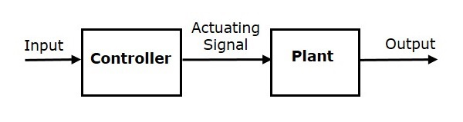

Figure 2.8 Open Loop Control System

#### Closed Loop

A Closed-loop Control System, also known as a feedback control system is a control system which uses the concept of an open loop system as its forward path but has one or more feedback loops between its output and its input. The reference to “feedback”, simply means that some portion of the output is returned “back” to the input.

Closed-loop systems are designed to automatically achieve and maintain the desired output condition by comparing it with the actual condition. It does this by generating an error signal which is the difference between the output and the reference input. In other words, a “closed-loop system” is a fully automatic control system in which its control action being dependent on the output in some way (Stouffer, Falco and Scarfone., 2011).

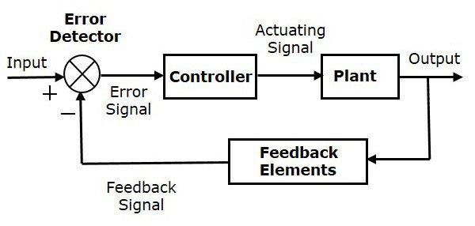

Figure 2.9 Closed Loop System

## Cloud Services

Cloud services provide many IT services traditionally hosted in-house, including provisioning an application/database server from the cloud, replacing in-house storage/backup with cloud storage and accessing software and applications directly from a web browser without prior installation.

Cloud services provide great flexibility in provisioning, duplicating and scaling resources to balance the requirements of users, hosted applications and solutions. Cloud services are built, operated and managed by a cloud service provider, which works to ensure end-to-end availability, reliability and security of the cloud (Schulz., 2011).

### Types of Cloud Services:

#### Software as a service (SaaS)

Used for web-based applications. SaaS is a method for delivering software applications over the Internet where cloud providers host and manage the software applications making it easier to have the same application on all of your devices at once by accessing it in the cloud.

#### Infrastructure as a service (IaaS)

Used for Internet-based access to storage and computing power. The most basic category of cloud computing types, IaaS lets you rent IT infrastructure - servers and virtual machines, storage, networks, and operating systems - from a cloud provider. (Miller., 2008).

#### Platform as a service (PaaS)

Gives developers the tools to build and host web applications. PaaS is designed to give users access to the components they require to quickly develop and operate web or mobile applications over the Internet, without worrying about setting up or managing the underlying infrastructure of servers, storage, networks, and databases (Rayes, and Salam., 2017).

### Cloud Services Providers

* Amazon Web Service (AWS)
* Heroku
* Microsoft Azure
* Google Cloud Platform
* IBM Cloud Services
* Adobe Creative Cloud
* Oracle Cloud
* SAP
* Dropbox

## Data Forecasting

This is an art of making predictions, projections, or estimates of some future activity, event, or  
occurrence. Soil moisture prediction makes use of forecasting models to predict the future moisture contents of a field.

### Types of Forecasting Methods

There ae two types of methods

* Qualitative methods
* Quantitative methods

#### Qualitative methods

These types of forecasting methods are based on judgments, opinions, intuition, emotions, or personal experiences and are subjective in nature. They do not rely on any rigorous mathematical computations.

Figure 2.10 Qualitative Forecasting Methods

#### Quantitative methods

These types of forecasting methods are based on mathematical (quantitative) models, and are objective in nature. They rely heavily on mathematical computations

Figure 2.11 Quantitative Forecasting Methods

##### Time Series Models

###### Naïve

Uses last period’s actual value as a forecast

###### Simple Mean (Average)

Uses an average of all past data as a forecast

###### Simple Moving Average

Uses an average of a specified number of the most recent observations, with each observation receiving the same weight.

###### Weighted Moving Average

Uses an average of a specified number of the most recent observations, with each observation receiving a different weight.

###### Exponential Smoothing

A weighted average procedure with weights declining exponentially as data become older

###### Trend Projection

Technique that uses the least squares method to fit a straight line to the data

###### Seasonal Indexes

A mechanism for adjusting the forecast to accommodate any seasonal patterns inherent in the data

###### Long Short-Term Memory

This is a deep learning algorithm that is able to learn from an entire data-set and make forecasts on the future data.

### Neural Networks

A neural network is a network or circuit of neurons, connected by weights. A positive weight reflects an excitatory connection, while negative values mean inhibitory connections. All inputs are modified by a weight and summed. This activity is referred to as a linear combination. Finally, an activation function controls the amplitude of the output. For example, an acceptable range of output is usually between 0 and 1, or it could be −1 and 1.

These artificial networks may be used for predictive modeling applications where they can be trained via a dataset. Self-learning resulting from experience can occur within networks, which can derive conclusions from a complex and seemingly unrelated set of information.

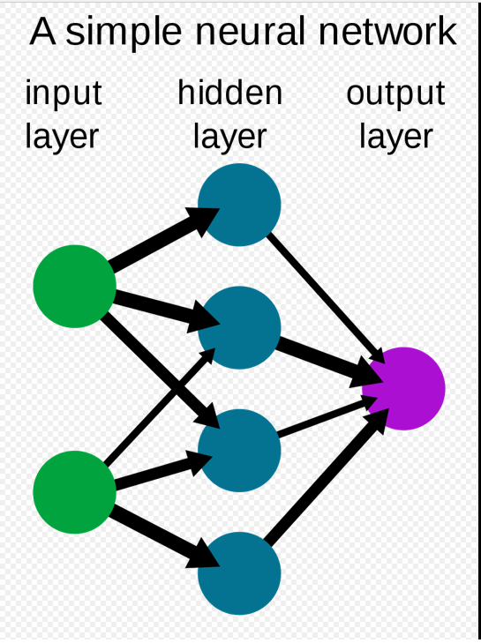

Figure 2.12 Neural Network

#### Machine Learning

This is an Artificial Intelligence technique which is a self-adaptive algorithm that gets increasingly better analysis and patterns with experience or with newly added data.

##### Deep Learning

This a subset of machine learning, utilizes a hierarchical level of artificial neural networks to carry out the process of machine learning. The artificial neural networks are built like the human brain, with neuron nodes connected together like a web. Deep learning systems enables machines to process data with a nonlinear approach.

###### Feed Forward Neural Network

The FFNN, also known as the multilayer perceptron (MLP) network, is built by ordering neurons  
in layers and letting each neuron in a layer take as input only the outputs of the units in the previous  
layer or external inputs. A network with *N* = 1, 2, 3, . . ., *n* layers is called an *n* layer network.

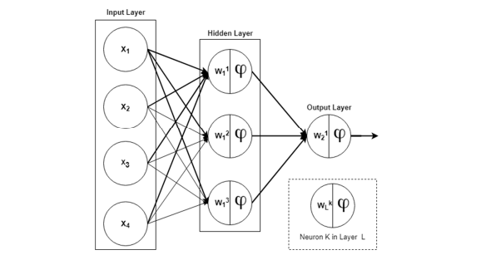

Figure 2.13 Feed Forward Neural Network

The second layer in the above Figure is called the output layer as it produces the output of the network (y). The first layer is known as the hidden layer since it is located between the external inputs and the output layer.

The value of the weights in the network determine how intelligent the model is. These weights are adjusted to find weights which produce the least error through a process called training. In order to determine the value of the weights, the network is trained with data containing examples of the inputs and outputspairs, known as the training set. The weights are chosen to minimize a global loss function, which measures the cost of predicting *y*ˆ when the true output *y* is a function over the training set

###### Recurrent Neural Network

Recurrent neural networks are similar to FFNNs except that there is a self-feedback of neurons in  
the hidden layers as illustrated in Figure below. This gives the network memory and it is able to learn from  
an entire sequence given portions of the overall sequence, i.e., it is a dynamic system.

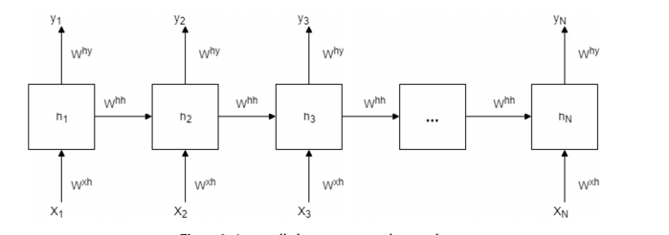

Figure 2.14 Recurrent Neural Network

The loss is calculated as the total loss for each time-step and the gradients are computed via  
back-propagation through time (BPTT). However, BPTT is not able to learn a pattern from long-term dependency because of the gradient vanishing problems. The RNNs use their back-coupling connections to memorize short-term dependency in a sequence as a result, the backpropagated error signals in time can become infinitely high or vanish. Long Short-Term Memory were proposed to be able to solve the exploding or vanishing gradients problem by enforcing constant error flows through constant error carousels within special multiplicative units.

###### Long Short-Term Memory

This an artificial recurrent neural network (RNN) architecture used in the field of deep learning. Unlike standard feedforward neural networks, LSTM has feedback connections. It can process single data points (such as images) and also entire sequences of data (such as speech or video).

A common LSTM unit is composed of a cell, an input gate, an output gate and a forget gate. The cell remembers values over arbitrary time intervals and the three *gates* regulate the flow of information into and out of the cell.

LSTM networks are well-suited to classifying, processing and making predictions based on time series data, since there can be lags of unknown duration between important events in a time series. LSTMs were developed to deal with the vanishing gradient problem that can be encountered when training traditional RNNs.

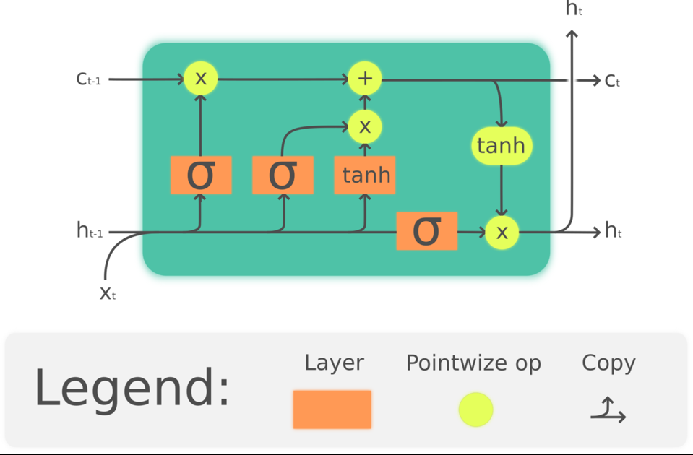

Figure 2.15 Long Short – Term Memory Cell

* Xt: input vector to the LSTM unitf t ∈ R h {\displaystyle f_{t}\in \mathbb {R} ^{h}}
* h t ∈ R h {\displaystyle h_{t}\in \mathbb {R} ^{h}} ht: hidden state vector also known as output vector of the LSTM unit
* c ~ t ∈ R h {\displaystyle {\tilde {c}}_{t}\in \mathbb {R} ^{h}} c t ∈ R h {\displaystyle c_{t}\in \mathbb {R} ^{h}} ct: cell state vectorW ∈ R h × d {\displaystyle W\in \mathbb {R} ^{h\times d}}

## Hardware

### Micro-controllers and Processors

A microcontroller is a single on chip computer which includes number of peripherals like RAM, EEPROM, Timers etc., required to perform some predefined task. There are different microcontroller families including: 8051, PIC (Programmable Interface Controller) and AVR. Microcontrollers are used in digital applications as control units. Some microcontrollers come with their in-build circuits like Analog to digital convertors or digital to analog convertors. Microcontrollers are mostly programmed using assembly language but in recent years high level languages like C, C++ PASCAL and java have been used. High level programming of microcontrollers brings the advantage of not having a different program for each microcontroller manufacturer. High level programming is also neat, easy to document and maintain and user friendly (Parab, et al., 2007).

#### Types of Micro-controllers

##### 8051

These are among the earlier microcontrollers to be fabricated. Due to superiority in technology in the newer versions, very few companies still fabricate 8051. Earlier types of 8051 have 12 clocks per instruction whereas the newer versions have 6 clocks per instruction. 8051 microcontrollers do not have an in-built memory bus and ADC. First 8051 microcontrollers to be fabricated with Harvard architecture was done in 1980 by Intel (Parab, et al., 2007).

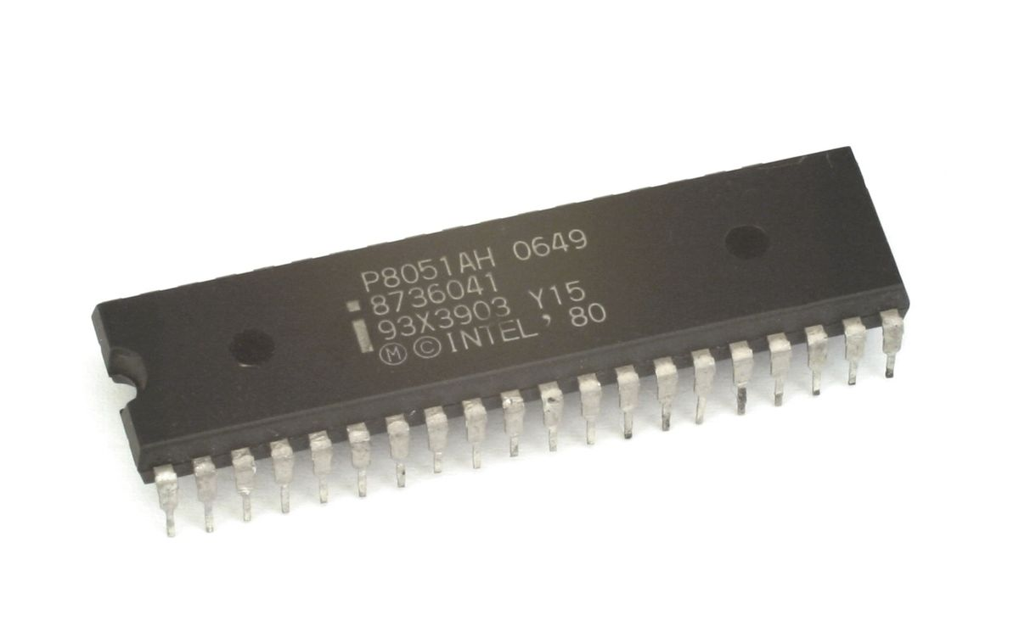

Figure 2.16 8051 Microcontroller

##### Programmable Interface Controller (PIC)

Programmable Interface Controllers are commonly referred to as PIC. PICs are slightly older than 8051 microcontrollers. PICs are preferred to 8051 because of their small low pin count devices. PICs perform better and are affordable than 8051. The Microchip technology fabricated the single chip microcontroller PIC with Harvard architecture. The only major downside of PIC is its programming part is very tedious. PICs are hence not recommended for beginners (Parab, et al., 2007).

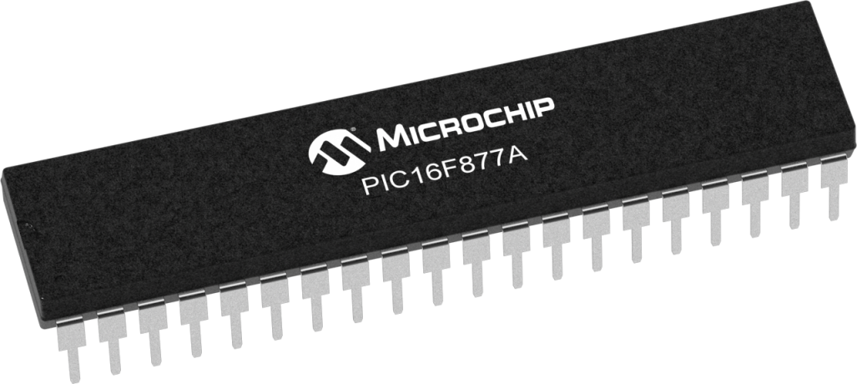

Figure 2.17 PIC Microcontroller

##### AVR

In 1996, Atmel fabricated this single chip microcontroller with a modified Harvard Architecture. This chip is loaded with C- compiler and a free IDE. Like PIC, AVR microcontrollers are difficult for the beginners to work with. AVR microcontroller has on-chip boot-loader thus AVR can be programmed easily without any external programmer. AVR controllers has number of I/O ports, timers/counters, interrupts, A/D converters, USART, I2C interfaces, PWM channels, on-chip analog comparators.

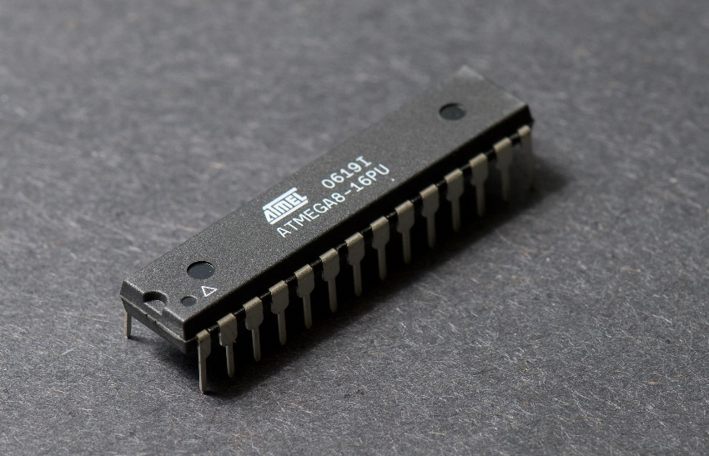

Figure 2.18 Atmel AVR Microcontroller

#### Arduino Boards

Arduino is an open-source electronics design platform. The Arduino board is specially designed for programming and prototyping with Atmel microcontrollers. An Arduino interacts with physical world via sensors. Using Arduino; electric equipment can be designed to respond to change in physical elements like temperature, humidity, heat or even light. This is the automation process. For example, reading a humidity sensor and turning on and off of an automatic irrigation system. There several types of Arduino boards. The open-source Arduino environment allows one to write code and load it onto the Arduino board's memory. The development environment is written in Java and based on Processing, AVR-GCC, and other open source software. The Arduino programming language is an implementation of Wiring, a similar physical computing platform, which is based on the Processing multimedia programming environment. The Arduino software is published as open source tools, available for extension by experienced programmers. The language can be expanded through C++ libraries, and people wanting to understand the technical details can make the leap from Arduino to the AVR C programming language on which it's based. Similarly, AVR-C code can be added directly into the Arduino programs if one so wishes (Barrett., 2013).

##### Arduino Uno

This is the most common Arduino type. This Arduino type uses ATmega328 AVR microcontroller.

Features of the Arduino UNO:

* Microcontroller: ATmega328
* Operating Voltage: 5V
* Input Voltage (recommended): 7-12V
* Input Voltage (limits): 6-20V
* Digital I/O Pins: 14 (of which 6 provide PWM output)
* Analog Input Pins: 6
* DC Current per I/O Pin: 40 mA
* DC Current for 3.3V Pin: 50 mA
* Flash Memory: 32 KB of which 0.5 KB used by bootloader
* SRAM: 2 KB (ATmega328)
* EEPROM: 1 KB (ATmega328)
* Clock Speed: 16 MHz

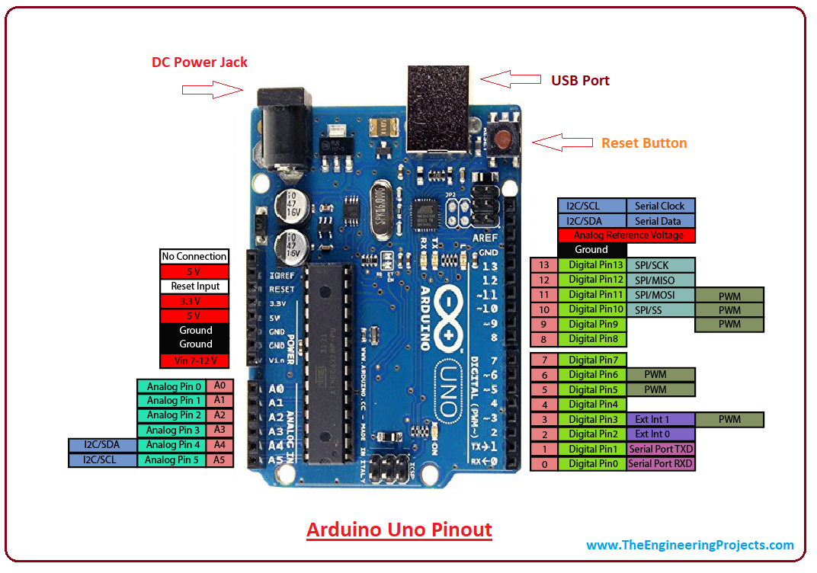

Figure 2.19 Arduino Uno

##### Arduino Mega 2560

This is regarded as an advancement of Arduino uno. It has more memory than Arduino uno. It has a total of 54 input pins of which 16 are analog inputs. It has a larger PCB board than Arduino. Overall, it is more powerful than Arduino uno. This Arduino board is based on ATmega2560 (Barrett., 2013).

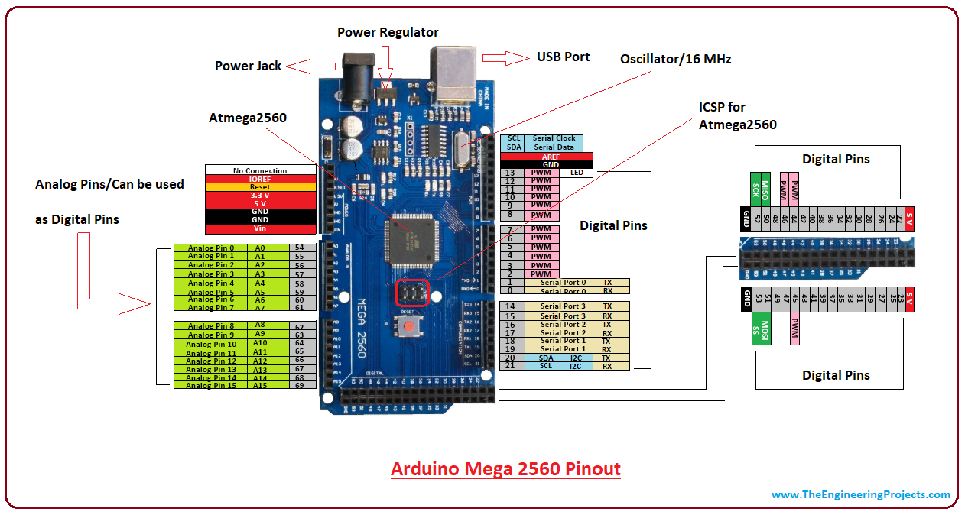

Figure 2.20 Arduino Mega2560

##### Arduino Lilypad

This Arduino board is designed for wearable applications. It is usually sewn on fabric. This board

requires the use of a special FTDI-USB TTL serial programming cable. Arduino Lilypad is used

to design "smart" wearable (Barrett., 2013).

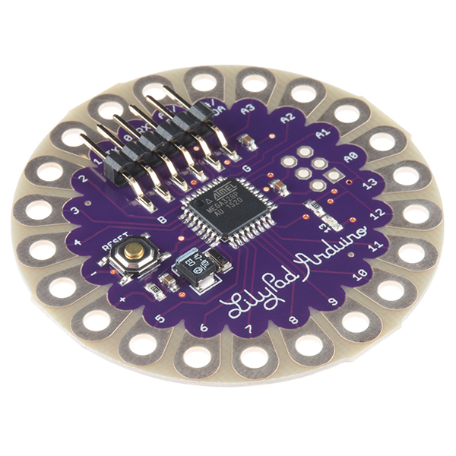

Figure 2.21 Arduino Lilypad

### Communication

Electronic communication is the meaningful exchange of information at a distance by technological means, particularly through electrical signals or electromagnetic waves.

#### Gsm Sim800L

SIM800L GSM/GPRS module is a miniature GSM modem. The module can accomplish almost anything a normal cell phone can SMS text messages, Make or receive phone calls, connecting to internet through GPRS and TCP/IP. The module supports quad-band GSM/GPRS network, meaning it works pretty much anywhere in the world (Una,2004).

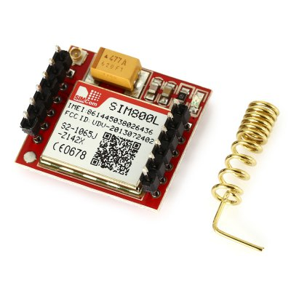

Figure 2.22 Sim800L GSM Module

##### Hardware Overview

All the necessary data pins of SIM800L GSM chip are broken out to 0.1″ pitch headers. This includes pins required for communication with a microcontroller over UART. The module supports baud rate from 1200bps to 115200bps with Auto-Baud detection

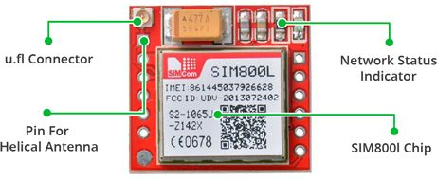

Figure 2.23 Sim800L GSM Module

This module measures 1-inch² but packs a lot of features into its little frame. Some of them are listed below:

* Supports Quad-band: GSM850, EGSM900, DCS1800 and PCS1900
* Connect onto any global GSM network with any 2G SIM
* Make and receive voice calls using an external 8Ω speaker & electret microphone
* Send and receive SMS messages
* Send and receive GPRS data (TCP/IP, HTTP, etc.)
* Scan and receive FM radio broadcasts
* Transmit Power:
  + Class 4 (2W) for GSM850
  + Class 1 (1W) for DCS1800
* Serial-based AT Command Set
* FL connectors for cell antennae
* Accepts Micro SIM Card

#### Esp8266

The ESP8266 is a low-cost Wi-Fi microchip, with a full TCP/IP stack and microcontroller capability, produced by Espressif Systems (Pharaskhanewala et al., 2009).

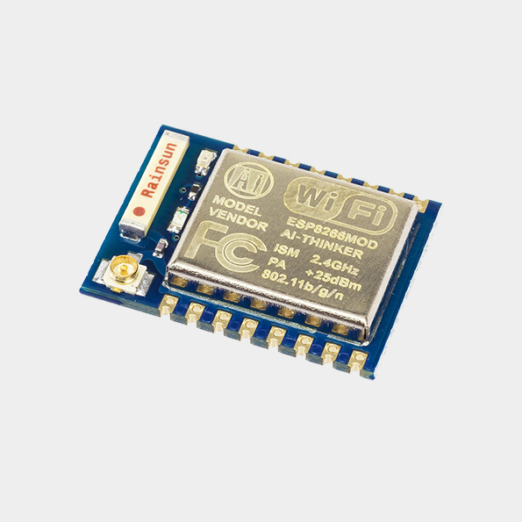

Figure 2.24 ESP8266 Wi-Fi Module

##### Features

* Processor: L106 32-bit RISC microprocessor
* Memory:
  + 32 KiB instruction RAM
  + 32 KiB instruction cache RAM
  + 80 KiB user-data RAM
  + 16 KiB ETS system-data RAM
* IEEE 802.11 b/g/n Wi-Fi
* 16 GPIO pins
* SPI
* I²C (software implementation)
* I²S interfaces with DMA (sharing pins with GPIO)
* UART on dedicated pins, plus a transmit-only UART can be enabled on GPIO2
* 10-bit ADC

### Data Storage

The micro- SD Card Module is a simple solution for transferring data to and from a standard SD card. The pin out is directly compatible with microcontrollers and processors. It allows you to add mass storage and data logging to any project (Ibrahim, 2010).

This module has SPI interface which is compatible with any sd card and it use 5V or 3.3V power supply which is compatible with Arduino UNO/Mega.

SD module has various applications such as data logger, audio, video, graphics. This module will greatly expand the capability an Arduino can do with their poor limited memory.

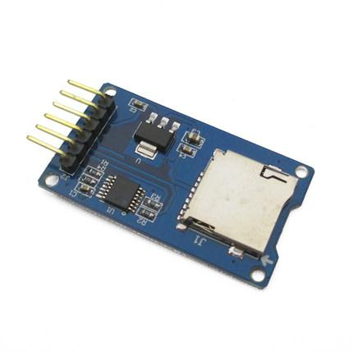

Figure 2.25 SD Card Data Logger

#### Specifications

* Working Voltage: 5V/3.3V
* Size:20x28mm
* Interface: SPI
* Compatible: MicroSD

### Sensors

A sensor is a device that detects and measures a physical quantity from the environment and converts it into an electronic signal. The physical quantity could be moisture, temperature, motion, light or any other physical phenomenon. Examples of sensors include: oxygen sensors, temperature sensors, infra-red sensors, humidly sensors, soil moisture sensors and motion detection sensors. The output of the sensors is usually charge, current or voltage. Of interest in this paper is the soil moisture sensor (Ahuja and Parande., 2012).

#### Soil Moisture Sensors

A soil moisture sensor is a device that measures the volumetric water content (VWC) of soil. Mathematically VWC, θ, is given as follows

$$θ=\frac{V_{W}}{V_{T}}$$

Where: VW is the water volume and VT is the total volume (soil volume + water volume). Soil moisture sensors are classified according to how they measure the soil moisture content.

##### Types of soil moisture sensors

###### Capacitance sensors

Capacitance sensors use frequency domain reflectometry (FDR). Frequency domain reflectometry is the measure of signal reflections through a medium across frequency. Capacitance sensors contain two electrodes which are separated by a dielectric material. The soil becomes the dielectric component after the electrodes are inserted into the soil; it could even be inserted into the access tube in the soil to achieve the same results. A high oscillating frequency is thereafter applied to the electrodes to induce a resonant frequency. The magnitude of the resonant frequency is dependent on the dielectric constant of the soil which in turns depends on or can change to the soil’s moisture content. The change of the frequency as a result of the soil’s moisture content is converted into the measurement of the soil moisture (Kelleners et al, 2004).

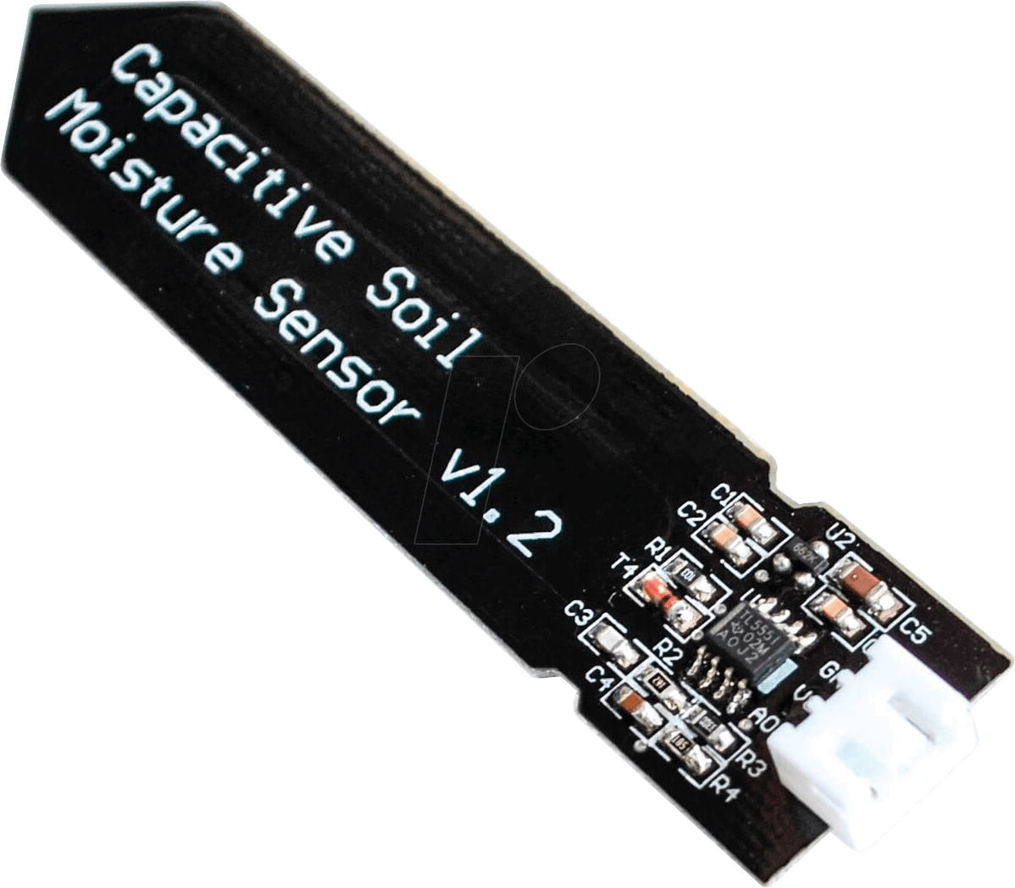

Figure 2.26 Capacitive Soil Moisture Sensor

###### Time Domain Reflectometry (TDR) sensors

Time Domain Reflectometry uses the principle of waveguides. The actual content of water in the soil is measured under this technology and not the water potential. The TDR device sends signals to the rods inserted in the soil. The time required for an electromagnetic signal to travel along the wave guide is measured. The rate at which the send signal returns is used to measure the water content in the soil. The return rate is dependent on the dielectric properties of the soil. The signal takes longer time in moisture soils and shorter time in dry soil. This pulse signal is then converted into soil moisture measurement. TDR sensors give accurate readings faster and require very little maintenance (Robinson et al, 2003). The major disadvantage of TDR sensors is that they require different calibrations depending on different soil types

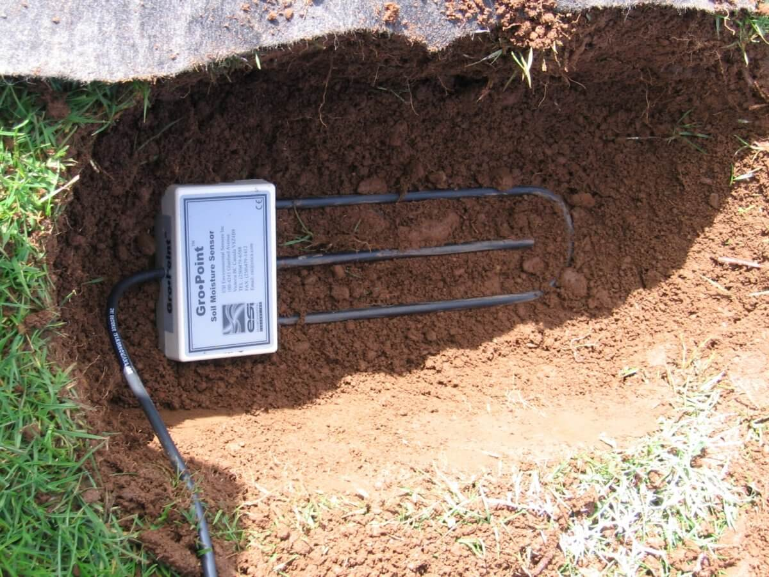

Figure 2.27 Time Domain Reflectometry Sensor

###### Electrical Resistance Blocks Sensors

These sensors are made up of two electrodes made from a porous substance like sand ceramic mixture or gypsum. The two electrodes are imbedded in the soil during installation. Moisture is allowed to move freely in and out of the sensors electrodes as the soil becomes moist or dries up. The resistance of the electrodes to the flow current is correlated with moisture content. To measure this resistance the electrodes are biased (energized) with a dc voltage and the current flowing through them measured. Applying Ohm’s law (Pardossi et al, 2009).

$R= \frac{V}{I}$

Where: R is resistance (Unknown) (Ω)

V is biasing voltage (3.3V to 5.0V)

I is the current flowing through the electrodes (Amps)

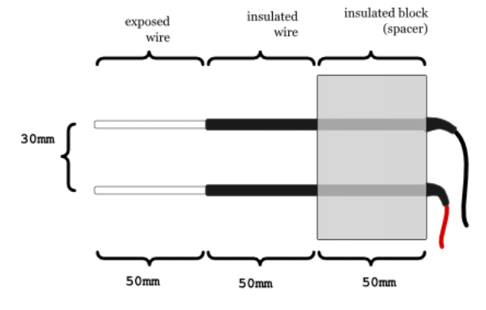

Figure 2.28 Resistive Moisture Sensor

#### Temperature Sensors

A temperature sensor is a device, usually an RTD (resistance temperature detector) or a thermocouple, that collects the data about temperature from a particular source and converts the data into understandable form for a device or an observer. Temperature sensors are used in many applications like HV and AC system environmental controls, food processing units, medical devices, chemical handling and automotive under the hood monitoring and controlling systems

The most common type of temperature sensor is a thermometer, which is used to measure temperature of solids, liquids and gases. It is also a common type of temperature sensor mostly used for non-scientific purposes because it is not so accurate.

##### Types of Temperature Sensors

###### Thermocouples

Thermocouple sensor is the most commonly used temperature sensor and it is abbreviated as TC. This sensor is extremely rugged, low-cost, self-powered and can be used for long distance. There are many types of temperature sensors that have a wide range of applications.

A thermocouple is a voltage device that indicates temperature by measuring a change in the voltage. It consists of two different metals: opened and closed. These metals work on the principle of thermo-electric effect. When two dissimilar metals produce a voltage, then a thermal difference exists between the two metals. When the temperature goes up, the output voltage of the thermocouple also increases.

This thermocouple sensor is usually sealed inside a ceramic shield or a metal that protects it from different environments. Some common types of thermocouples include K, J, T, R, E, S, N, and B. The most common type of thermocouples is J, T and K type thermocouples, which are available in pre-made forms.

The most important property of the thermocouple is nonlinearity – the output voltage of the thermocouple is not linear with respect to temperature. Thus, to convert an output voltage to a temperature, it requires mathematical linearization.

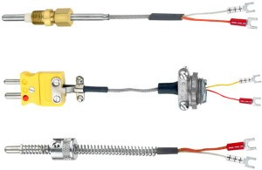

Figure 2.29 Thermocouple Sensor

###### Resistor Temperature Detector (RTD)

RTD sensor is one of the most accurate sensors. In a resistor temperature detector, the resistance is proportional to the temperature. This sensor is made from platinum, nickel, and copper metals. It has a wide range of temperature measurement capabilities as it can be used to measure temperature in the range between -270oC to +850oC. RTD requires an external current source to function properly. However, the current produces heat in a resistive element causing an error in the temperature measurements.

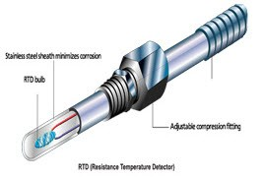

Figure 2.30 Resistor Temperature Detector

###### Thermistors

Another type of sensor is a thermistor temperature sensor, which is relatively inexpensive, adaptable, and easy to use. It changes its resistance when the temperature changes like RTD sensor. Thermistors are made from manganese and oxides of nickel, which make them susceptible to damages. So, these materials are called ceramic materials. This thermistor offers higher sensitivity than the resistor temperature detectors. Most of the thermistors have a negative temperature coefficient. It means, when the temperature increases the resistance decreases.

###### Thermometers

A thermometer is a device used to measure the temperature of solids, liquids, or gases. The name thermometer is a combination of two words: thermo – means heat, and meter means to measure. Thermometer contains a liquid, which is mercury or alcohol in its glass tube. The volume of the thermometer is linearly proportional to the temperature – when the temperature increases, the volume of the thermometer also increases.

When the liquid is heated it expands inside the narrow tube of the thermometer. This thermometer has a calibrated scale to indicate the temperature. The thermometer has numbers marked alongside the glass tube to indicate the temperature when the line of mercury is at that point. The temperature can be recorded in these scales: Fahrenheit, Kelvin or Celsius. Therefore, it is always desirable to note for which scale the thermometer is calibrated.

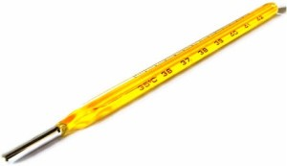

Figure 2.31 Thermometer

###### Semiconductor Sensors

Semiconductor sensors are the devices that come in the form of ICs. Popularly, these sensors are known as an IC temperature sensor. They are classified into different types: Current output temperature sensor, Voltage output temperature sensor, Resistance output silicon temperature sensor, Diode temperature sensors and Digital output temperature sensor. Present semiconductor temperature sensors offer high linearity and high accuracy over an operating range of about 55°C to +150°C. However, AD590 and LM35 temperature sensors are the most popular temperature sensors.

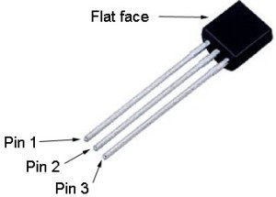

Figure 2.32 LM35 Sensor

###### IR sensor

IR sensor is an electronic instrument which is used to sense certain characteristics of its surroundings by either emitting or detecting IR radiation. These sensors are non-contacting sensors. For example, if you hold an IR sensor in front of your desk without establishing any contact, the sensor detects the temperature of the desk based on the merit of its radiation. These sensors are classified into two types such as thermal infrared sensors and quantum infrared sensors.

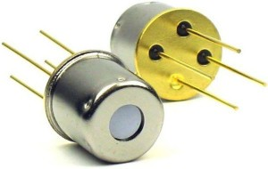

Figure 2.33 IR sensor

#### Humidity Sensors

A humidity sensor (or hygrometer) senses, measures and reports both moisture and air temperature. The ratio of moisture in the air to the highest amount of moisture at a particular air temperature is called relative humidity. Humidity sensors work by detecting changes that alter electrical currents or temperature in the air.

##### Types of Humidity Sensors

###### Capacitive

A capacitive humidity sensor measures relative humidity by placing a thin strip of metal oxide between two electrodes. The metal oxide’s electrical capacity changes with the atmosphere’s relative humidity. Weather, commercial and industries are the major application areas.

The capacitive type sensors are linear and can measure relative humidity from 0% to 100%. The catch here is a complex circuit and regular calibration. However, for designers this a lesser hassle over precise measurement and hence these dominate atmospheric and process measurements. These are the only types of full-range relative humidity measuring devices down to 0% relative humidity. This low-temperature effect often leads to them being used over wide temperature ranges without active temperature compensation.

###### Resistive

Resistive humidity sensors utilize ions in salts to measure the electrical impedance of atoms. As humidity changes, so do the resistance of the electrodes on either side of the salt medium.

###### Thermal

Two thermal sensors conduct electricity based upon the humidity of the surrounding air. One sensor is encased in dry nitrogen while the other measures ambient air. The difference between the two measures the humidity.

##### DHT 22 Sensor

The DHT-22 (also named as AM2302) is a digital-output relative humidity and temperature sensor. It uses a capacitive humidity sensor and a thermistor to measure the surrounding air, and gives out a digital signal on the data pin.

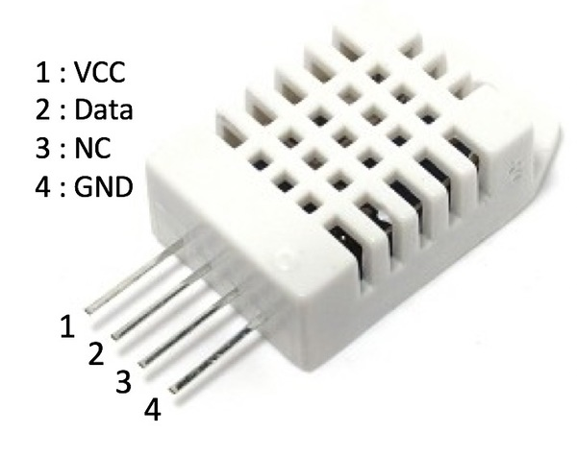

Figure 2.34 DHT22 Sensor

#### Sensor Selection

When deciding on which sensor to use the following factors should be put into consideration:

* **Price**: This is the most important parameter when selecting any component. The price of the sensor will ultimately affect the price of the whole system as this is one of the major system modules. Sensor with the most competitive price should be chosen.
* **Power**: In any electrical system power efficiency is critical. Moisture sensor will low power consumption should be selected. Sensors which can be battery powered can be used in areas without electricity connection.
* **Technology**: Technology used to design sensor dictate the sensitivity, cost and durability of the sensors. Most low-cost sensors have poor sensitivity, rust and corrode over time. Resistive or conductive sensors which are affected by soli salinity thus have a short life.
* **Shape**: Long and slender sensors can be used in many applications than bulky ones.
* **Durability**: Soil moisture sensor which are not affected by soil salinity, corrode or rust should be selected. Soil moisture sensor probes that measure conductivity or resistance should be avoided, since they will wear out over time.
* **Accuracy and Linearity**: A quality soil moisture sensor probe should give an output which is proportional to water content over the full output range. In addition, the soil moisture sensor probe should have a good output range to reduce sensitivity to noise.
* **Voltage Range**: Choose a sensor that has a big supply voltage range. Powering a sensor with the wrong voltage will damage the sensor or give inaccurate results.

### Displays

Liquid Crystal Display (LCD) screen is an electronic display module. An LCD has a wide range  
of applications in electronics. The most basic and commonly used LCD in circuits is the 20-x 4  
display. LCDs are commonly preferred in display because they are cheap, easy to program  
and can display a wide range of characters and animations. A 20 x 4 LCD have two display lines each capable of displaying 20 characters. This LCD has Command and Data registers. The command registers stores command instructions given to the LCD while the Data register stores the data to be displayed by the LCD.

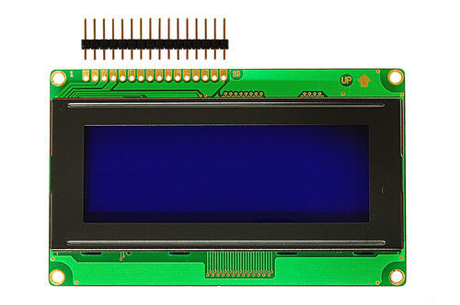

Figure 2.35 20-x-4 LCD

When using 8-bit configuration all 8 data pins (DB0-DB7) are used while only 4 data pins (DB4-

DB7) are used in a 4-bit configuration.

|  |  |  |
| --- | --- | --- |
| **Pin number** | **Function** | **symbol** |
| 1 | Ground (0V) | VSS |
| 2 | Supply voltage (5V) | VDD |
| 3 | Contrast adjustment; through a variable resistor(potentiometer) | V0 |
| 4 | Selects command register when low; and data register when high | RS |
| 5 | Low to write to the register; High to read from the register | RW |
| 6 | Sends data to data pins when a high to low pulse is given | E |
| 7 | 8-bit data pins | D0 |
| 8 | 8-bit data pins | D1 |
| 9 | 8-bit data pins | D2 |
| 10 | 8-bit data pins | D3 |
| 11 | 8-bit data pins | D4 |
| 12 | 8-bit data pins | D5 |
| 13 | 8-bit data pins | D6 |
| 14 | 8-bit data pins | D7 |
| 15 | Backlight VCC (5V) | A |
| 16 | Backlight Ground (0V) | K |

# Chapter THREE METHODOLOGY

## Introduction

This chapter serves to outline the methodology that was used in order to accomplish the aforementioned aim and the objectives of the design project. It gives detailed information on data collection method, data analysis and evaluation techniques that were used. The methodology of the project includes a thorough review of literature outlined in the previous chapter

## System Design Approach

The Systematic Approach describes engineering design as a sequence of four phases: (1) Task Clarification, (2) Conceptual Design, (3) Embodiment Design, and (4) Detail Design. Task Clarification is concerned with collecting, formulating and documenting the requirements of the product to be designed. Conceptual Design aims to identify the basic principles and outline of a design solution (or concept). Embodiment Design then elaborates the design into a layout that satisfies various technical and economic criteria. Detail Design finalizes the design and prepares production documents. Each of the four phases comprises a sequence of activities that may be executed iteratively. After every phase a “decision-making step” is performed to assess the results of the phase and decide whether the subsequent phase can be started or whether the phase needs to reiterate. Table 3.1 shows the phases of Pahl and Beitz’ Systematic Approach, and the activities associated with each phase.

Table 3.1: Pahl and Beitz’ Systematic Approach to design.

|  |  |
| --- | --- |
| **Phases** | **Activities** |
| 1.Task clarification | * Define basic design requirements * Document customer-specific technical performance requirements * Refine and extend the requirements using the checklist and scenario planning * Determine demands |
| 2.Conceptual design | * Abstract to identify the essential problems * Establish function structures: overall function – sub functions * Search for working principles that fulfil the sub functions * Combine working principles into working structures * Select suitable combinations * Firm up into principle solution variants * Evaluate variants against technical and economic criteria |
| 3.Embodiment design | * Identify embodiment-determining requirements * Produce scale drawings of spatial constraints * Identify embodiment-determining main function carriers * Develop preliminary layouts and form designs for the embodiment-determining main function carriers * Select suitable preliminary layouts * Develop preliminary layouts and form designs for the remaining main function carriers * Search for solutions to auxiliary functions * Develop detailed layouts and form designs for the main function carriers ensuring compatibility with the auxiliary function carriers * Develop detailed layouts and form designs for the auxiliary function carriers and complete the overall layouts * Evaluate against technical and economic criteria * Optimize and complete form designs * Check for errors and disturbing factors * Prepare preliminary parts lists and production documents |
| 4. Detail design | * Finalize details; complete detail drawings * Integrate into overall layout drawings, assembly drawings and parts lists * Complete production documents with production, assembly, transport and operating instructions * Check all documents for standards, completeness and correctness |

## Research Method

A mixed mode approach entails the use of both qualitative and quantitative research approaches leveraging both types of data to generate deeper, and ultimately more reliable, actionable and profitable research insights. Quantitative research deals with numbers and statistics, while qualitative research deals with words and meanings. Each of these types of research has different objectives and methods, and both are important for gaining different kinds of knowledge in meeting the aim and the objectives of the project. Figure 3.2 below shows the relationship between the quantitative and qualitative research methodologies building up the system design.

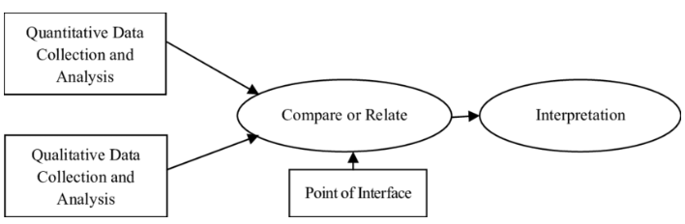

Figure 3.2: Mixed Mode Research

Qualitative and quantitative research focus on different types of data and they complement each other to have a conclusive information. Table 3.2 below the difference between these two research methodologies.

Table 3.2: Difference between Qualitative and Quantitative Research Methods

|  |  |
| --- | --- |
| **Qualitative Research Method** | **Quantitative Research Method** |
| Methods include focus groups, in-depth interviews and reviews of documents for types of themes. | Surveys, structured interviews and observations and reviews of records or documents for numeric information |
| Primarily inductive process used to formulate theory or hypothesis | Primarily deductive process used to test pre-specified concepts, constructs, and hypotheses that make up theory |
| More subjective: describes a problem from the point of view of those experiencing it | More objective: provides observed effects (interpreted by researchers) of a program on a problem or condition |
| Text-based | Number- based |
| More in-depth information on a few cases (more and deep collected information on a few cases) | Less in-depth but more breadth of information across a large number of cases (less shallow information but large number of cases) |
| Fixed response options | Unstructured or semi-structured response options |
| Statistical tests are used for analysis | No statistical tests |
| Can be valid and reliable: largely depends on the measurement device or instrument used | Can be valid and reliable: largely depends on skill and detail of the researcher. |
| Time expenditure heavier on the planning phase | Time expenditure lighter on the planning end and heavier on the analysis phase |
| More generalize | More specific |

### Qualitative Research

Qualitative Research is primarily exploratory research. It is used to gain an understanding of underlying reasons, opinions, and motivations. It provides insights into the problem or helps to develop ideas or hypotheses for potential quantitative research. Qualitative Research is also used to uncover trends in thought and opinions, and dive deeper into the problem. Qualitative data collection methods vary using unstructured or semi-structured techniques. Some common methods include focus groups (group discussions), individual interviews, and participation/observations and many more such as illustrated in Figure 3.3 below.



Figure 3.3 Qualitative Research Methods

During the process of gathering information related to the functionality, strength and weaknesses of the existing irrigation system currently being used in the fuel depots, some of the qualitative methods shown on above were used.

#### Consultation

Consultation is one of the qualitative data collection methods that was used. farmers were consulted to give a detailed information of their experience with the current irrigation systems that are being used.

Consultation gave the author the overview of the real problems of the existing systems. The design therefore has to answer to these problems and provide a solution to them. However, this method couldn’t provide all the necessary information required for the successful design of the proposed system.

#### Site Visits

The author conducted site visits at a greenhouse farm in Harare to obtain a deep understanding of how the current system operates. The problems which were stated by the operators during the consultation period were also observed.

#### Literature Review

With the curiosity to know how the aforementioned problems can be solved, the author used books, articles, internet searches and journals to look for the technologies that have been developed in order to provide an efficient, reliable irrigation system which can eliminate or reduce all the shortfalls of the manual open loop irrigation systems. Also, an in-depth search for the functionality of each of the components of the system was done through the literature review.

### Quantitative Research

Quantitative research is used to quantify the problem by way of generating numerical data or data that can be transformed into useable statistics. It is used to quantify attitudes, opinions, behaviors, and other defined variables – and generalize results from a larger sample population. Quantitative Research uses measurable data to formulate facts and uncover patterns in research. Quantitative data collection methods are much more structured than Qualitative data collection methods. Quantitative data collection methods include various forms of surveys – online surveys, paper surveys, mobile surveys and kiosk surveys, face-to-face interviews, telephone interviews, longitudinal studies, website interceptors, online polls, and systematic observations.

# CHAPTER FOUR: DESIGN CONCEPTION

## Introduction

This chapter focuses on the generation of concepts for smart irrigation scheduling. By combining ideas, potential solutions of the system are developed without getting in technical detail, although important factors will be addressed. The concepts are then evaluated using a number of tools so that their strengths and weaknesses are distinguished.

## Concept Generation

This section focuses on the description of the system's components and their configuration in the system. Using concept scoring, the best solution is selected based on different design criteria.

### Determination of Customer Requirements

Customer requirement determination is the first step in the product creation process and is one of the most significant as it contributes to the production of a consumer-based product. The consumer requirements were obtained from interviews with various horticulture farmers in Harare.

Consumer requirements:

* Efficiency of the irrigation system
* Ease of Use
* Taking other parameters into consideration which affect soil moisture content.
* Ease of Maintenance
* System Durability
* Remote Monitoring and Control
* Uniform monitoring of the field
* Precision and Accuracy in Responsiveness

## Generation of Concepts

### Concept A

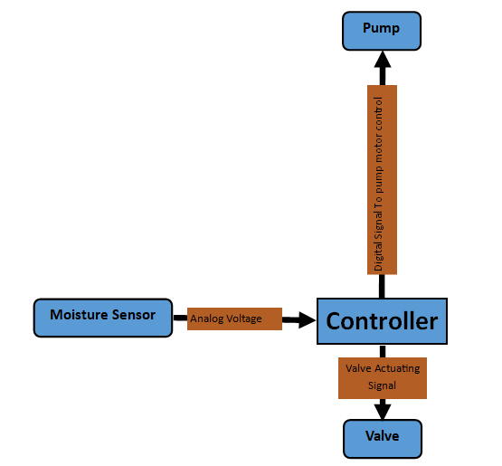

Figure 4.1 Concept A Block Diagram

#### Principle of operation

Soil Moisture sensor in the field sends analog signal to a controller depending on the water content in the soil. The controller processes the signal and depending on the set-points set on the controller a decision is made to irrigate or not. When the sensor input is below the setpoint a high signal is sent to the valve actuator to open the valve and also to the motor control contactor to start the pump motor. When the sensor input is above the setpoint, the controller sends low signals to the motor control contactor and valve actuator. The type of valve used is normally closed, only opens when the actuator receives a high signal from the controller. This concept uses on-demand irrigation scheduling, water is only delivered to the field when the moisture falls below the setpoint.

##### Flow-Chart

Read Sensor Value

Is Moisture below setpoint

Send High Signal to Motor and Valve Actuator

No

YES

Figure 4.2 Concept A Flow Chart

#### Advantages

* Easy to setup
* Easy to maintain as it is less complex
* Uses live data from sensors

#### Disadvantages

* Not resource efficient,
* Doesn’t take into consideration other parameters that affect soil moisture.
* It doesn’t have a notification interface
* Operators cannot remotely monitor

### Concept B

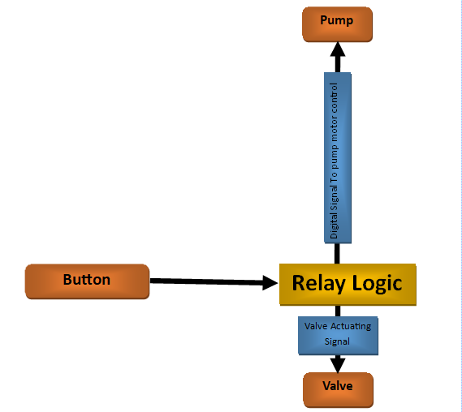

Figure 4.3 Concept B Block Diagram

#### Principle of operation

This concept uses relay logic. When you press the start button the field valve will be opened and pump will be started after sending high signals from the relay logic circuit to all control devices in the field.

##### Flow-Chart

Is Button Pressed

Read button State

Send High signal to Motor Control and Valve actuator

YES

NOO

Figure 4.4 Concept B Flow Chart

#### Advantages

* Easy to setup
* Easy to maintain as it is less complex
* Cheap to setup

#### Disadvantages

* Not resource efficient,
* Doesn’t take soil moisture into consideration.
* It doesn’t have a notification interface
* Operators cannot remotely monitor
* Rigid not flexible
* Operator has to constantly monitor the irrigation process

### Concept C

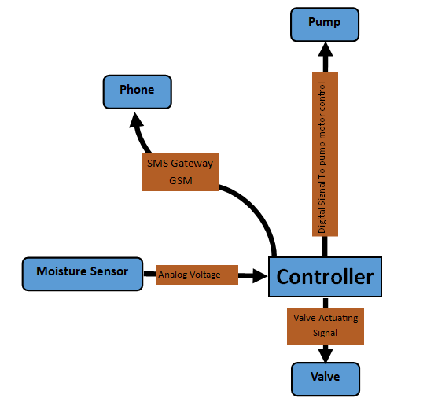

Figure 4.5 Concept C Block Diagram

#### Principle of operation

In this concept a controller acquires soil moisture values from the field sensor and a Proportional, Integral and Derivative algorithm set in the controller maintains the moisture content in the field by controlling the valve and pump to irrigate the field. It features a notification interface which allows the operator to remotely monitor the field.

##### Flow-Chart

Read Sensor Value

Is Moisture below setpoint

Send High Signal to Motor and Valve Actuator

No

YES

Is uptime – flag >30minutes

Send Moisture Value and logs to Operator

Clear logs  
flag = uptime

YES

No

Figure 4.6 Concept C Flow Chart

#### Advantages

* Allows remote monitoring
* Easy to setup
* Easy to maintain as it is less complex

#### Disadvantages

* Not resource efficient,
* Doesn’t take into consideration other parameters that affect soil moisture.
* It doesn’t have a notification interface
* Operators cannot remotely monitor

### Concept D

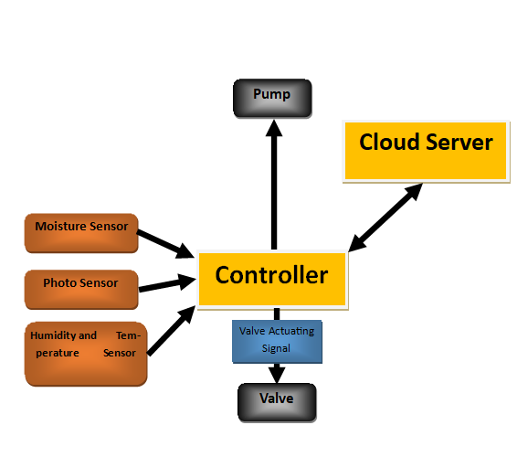

Figure 4.7 Concept D Block Diagram

#### Principle of operation

Controller acquires soil moisture, temperature, humidity and sunshine intensity from field sensor. Pre-processing of the signal is done on the controller and stored to a local SD-card. The data is sent to a cloud server on the internet for post processing. On the cloud server analysis of the data is done and a forecast of soil moisture for the coming days is done, a response is sent back to the controller with the specific moisture content that should be maintained. If there is need to irrigate the controller send high signals to motor pump control and valve actuator.

#### Advantages

* Takes in almost all aspects that affect soil moisture.
* Uses optimization prediction algorithms which predicts the right amount of water content which should be maintained
* Favors maximum yield as crops get the optimum water content.
* Saves on water usage as forecasting is incorporated.

#### Disadvantages

* Complex
* Needs a high skilled technician to maintain
* Lacks user interfaces.
* A break down on internet connection means the online server won’t be available to serve irrigation plan.
* Existence of a second server means the reliability of the system is compromised from a maintenance standpoint.
* Vulnerable to cyber-attacks.

## Concept Selection

In this section concept screening and concept scoring is going to be done to evaluate and select the best concept amongst the four concepts generated.

### Concept Screening

Basing on a list of parameters that define the selection criteria and making use of the concept as the reference concept. The table below shows the selection criteria and the comparisons

#### Key

+ : is better than

- : indicates is worse than

0 : indicates is same as

Table 4.1 Concept Screening

|  |  |  |  |  |  |
| --- | --- | --- | --- | --- | --- |
| **SELECTION CRITERIA** | **CONCEPT** | | | | |
| **A** | **B** | **C** | **D** | **Reference** |
| Ease of Use | 0 | + | + | 0 | 0 |
| Ease of Maintenance | 0 | + | 0 | - | 0 |
| Remote Monitoring and Control | - | - | + | - | 0 |
| Uniform monitoring of the field | - | - | + | + | 0 |
| Precision and Accuracy in Responsiveness | - | - | 0 | + | 0 |
| System Durability | + | 0 | 0 | + | 0 |
| Efficiency of the irrigation system | 0 | - | 0 | + | 0 |
| Considerations of other parameters | - | - | 0 | + | 0 |
| **Sum of “+” s** | 1 | 2 | 3 | 5 | 0 |
| **Sum of “0” s** | 3 | 1 | 5 | 1 | 8 |
| **Sum of “-” s** | 3 | 5 | 0 | 2 | 0 |
| **Net Score** | -2 | -3 | 3 | 3 | 0 |
| **Rank** | 3 | 4 | 1 | 1 | 0 |
| **Continue?** | NO | NO | YES | YES |  |

### Concept Scoring

This is a selection method that uses a scoring matrix to evaluate concept alternative, heavily considering the strengths and weaknesses of each. The designer will be selecting one concept which will be the best according to the criteria used and will have the better scores than all of the other concepts.

Table 4.2 Concept Scoring

|  |  |  |  |  |  |  |  |
| --- | --- | --- | --- | --- | --- | --- | --- |
| **SELECTION**  **CRITERIA** | **WEIGHTS**  **%** | **CONCEPTS** | | | | | |
| **C** | | **D** | | **C+D** | |
|  |  |  |  |  |  |
| **Rank** | **Weight** | **Rank** | **Weight** | **Rank** | **Weight** |
| Ease of Use | 10 | 4 | 0.4 | 3 | 0.3 | 3 | 0.3 |
| Ease of Maintenance | 13 | 4 | 0.52 | 3 | 0.39 | 3 | 0.39 |
| Cost | 5 | 4 | 0.2 | 3 | 0.15 | 2 | 0.1 |
| Remote Monitoring and Control | 30 | 0 | 0 | 4 | 1.2 | 5 | 1.5 |
| Uniform monitoring of the field | 22 | 2 | 0.44 | 3 | 0.66 | 4 | 0.88 |
| Precision and Accuracy in Responsiveness | 10 | 2 | 0.2 | 3 | 0.3 | 3 | 0.3 |
| System Durability | 6 | 3 | 0.18 | 2 | 0.12 | 3 | 0.18 |
| Considerations of other parameters | 4 | 1 | 0.04 | 3 | 0.12 | 4 | 0.16 |
| Total Score |  | 1.98 | | 3.24 | | 3.81 | |
| Rank |  | 3 | | 2 | | 1 | |
| Continue? |  | N0 | | NO | | YES(Develop) | |
|  |  |  | |  | |  | |

## Selection of Forecasting Model

From Chapter 2, different types of forecasting data have been reviewed. A Deep Learning Algorithm will be selected for this project because of reliability and accuracy in prediction over all other prediction methods. Deep learning models have a strong learning ability and are able to represent the nonlinear relationship between the inputs and outputs of a system which other quantitative methods fails to do. Neural Networks can be applied in this study for predicting the soil moisture dynamics because of their ability to produce robust functions approximating complex processes.

### Long Short-Term Memory

Due to the failure of Recurrent Neural Network in learning patterns from long-term dependency because of the gradient vanishing problem caused by back propagation through time during training, a more advanced gated model of the RNN called LSTM will be used. LSTM uses three gated weights to avoid loss of long-term dependency. Losses are propagated uniformly throughout the network which gives the network more ability to learn.

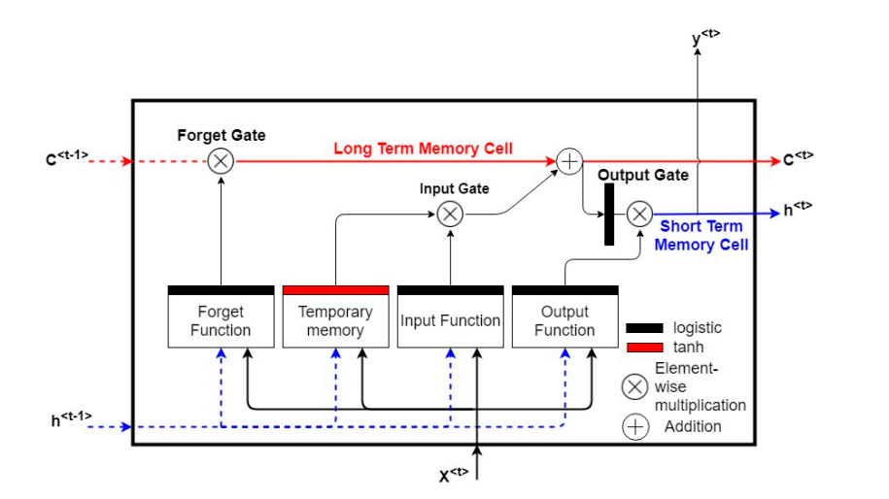

Figure 4.8 Long Short-Term Memory Cell

h<t-1> - Previous hidden cell state

X<t> - Input at time step t

C<t-1> - Previous Cell State

Y<t> - Predicted Output at time step t

## Proposed System

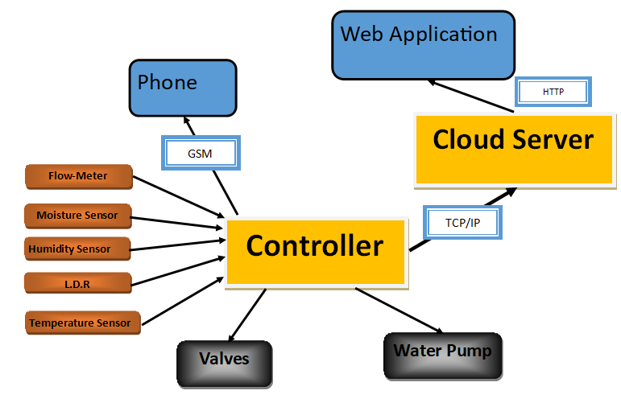

Figure 4.9 Proposed System Block Diagram

### Principle of operation

This model uses feedback from soil and climatic sensors to predict the crop water demand. A trained neural network model (LSTM) will be able to generate soil moisture predictions and presents an opportunity for implementing predictive irrigation scheduling. The neural network model trained for the field will be applied to generate a next time step prediction of soil moisture content using the climatic data.

The prediction will used to determine the irrigation depth and timing. This will form the basis of the predictive irrigation system which will be fully described in the detailed design chapter. Rule-based systems are programmed to apply irrigation based on specified soil moisture thresholds and applied water depths to refill the soil moisture content to field capacity. This system is a closed-loop system, which considers soil moisture feedback after irrigation events.

### Predictive Scheduling Block Diagram

**Soil Moisture Value**

**Climate data**

**LSTM Prediction Model**

**Irrigation Scheduling System**

**Crop Information**

**Controller**

**Soil Information**

**Irrigation Needed**

**Yes**

**No**

**Next Time Step**

Figure 4.10 Proposed System Block Diagram

### Program Flow-chart

Read Sensor Values

Is Moisture below setpoint

Send Request to server to get specific amount of water to irrigate

No

YES

Is uptime – flag >30minutes

Send Moisture Value and logs to Operator

Clear logs  
flag = uptime

YES

No

Post Data To Cloud

Turn on pump and open valve

Figure 4.11 Proposed System Flow System

## Summary

The chapter centred on the creation of various concepts and ideas that are capable of meeting the goals set out in this project document's first chapter. The concepts were then scored and screened, and selected the most appropriate one and will be developed in the chapters to come.

# CHAPTER FIVE: DETAILED DESIGN

## Introduction

The main objective of the project is to design and build a smart irrigation controller that will be  
able to predict next time step soil moisture content and optimize irrigation scheduling. This chapter gives the detailed design of the hardware controller, the control system which runs on the designed hardware, web application for interfacing the whole system and the development of prediction model using deep learning tools.

The controller consists of the following sections:

* **Hardware Controller** – it is the interface between the software (scheduling system) and devices(sensors) in the field. Sensors in the field post data to the controller which has a microcontroller for pre-processing of the signals before they are posted to the cloud server hosted on Heroku. The hardware controller also receives commands from the cloud server and send actuating signals to valves or messages via a GSM.
* **Control System** - this is responsible for the control of parameters i.e. soil moisture content in the field so as to maintain near perfect condition for crops to grow. The control system is built on C++ on the hardware side and Node.js on the server side.
* **Web Application** – This forms the interactive interface for the whole system for real-time monitoring and control of the irrigation process. Front-end of the app will be built using CSS, HTML and JavaScript. Back-end is built using Node.js
* **Prediction Model** – This predicts the moisture content for the next time step(hourly) and to determine the most accurate irrigation depth and timing. The model uses a 1-dimensional Convolutional Neural Network which is a good forecasting algorithm.

## Control System

This section focuses on the design of the control system for the irrigation controller.

### Introduction

Irrigation is an important farming input which is sensitive and real-time monitoring and control of watering activities can be paramount.

### Development of Microcontroller Program

#### Libraries and Function Definition

The figure below shows the code snippet for the importing of libraries that will be used in the control system

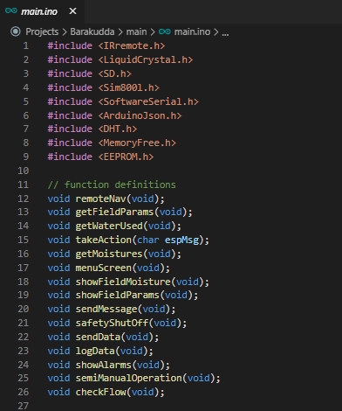

Figure 5.1 Importing Libraries and function definitions

#### Microcontroller Set-up Routine

Void setup() function runs once when the microcontroller boots and it initializes all hardware connected.

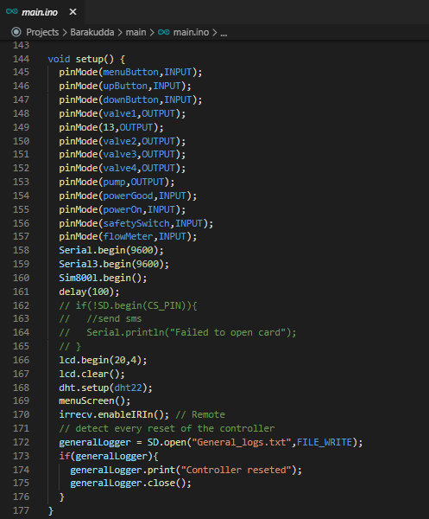

Figure 5.2 Program setup routine

#### Data Acquisition

The controller consists of two microcontroller chips embedded on the same board which are

1. Mega2560 MCU – connects all periphery devices.
2. ESP8266 MCU – gives the whole system the ability to connect to the internet via Wi-Fi

The Mega2560 receives sensor input where all pre-processing takes place and sends the data to the ESP8266 via serial communication.

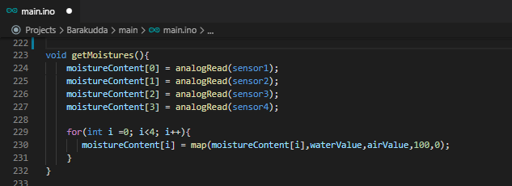

Figure 5.3 Moisture Data acquisition

For the sake of this project a simulation of 4 fields is done and each field consist of its own moisture sensor. Function void getMoistures() sample all field moistures and updates the moistureContent array. The moistureContent array consists of the real-time moisture values for all the fields.

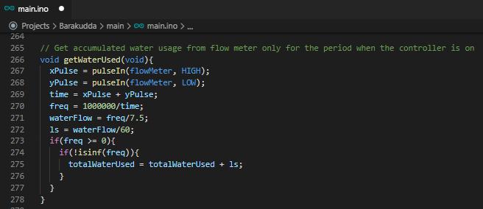

Figure 5.4 Flow Meter Routine to measure flow rate

A flow meter was incorporated to calculate the water usage and the function void getWaterUsed() updates the totalWaterUsed variable with the total water used.

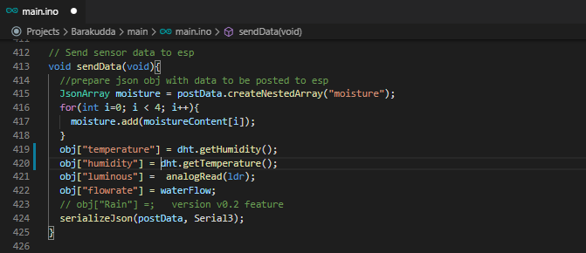

Figure 5.5 Function to send data to ESP8266

Function sendData() acquires humidity, temperature and sunshine intensity for the sensors and sends the data as a JSON object on the serial port.

#### Actuation

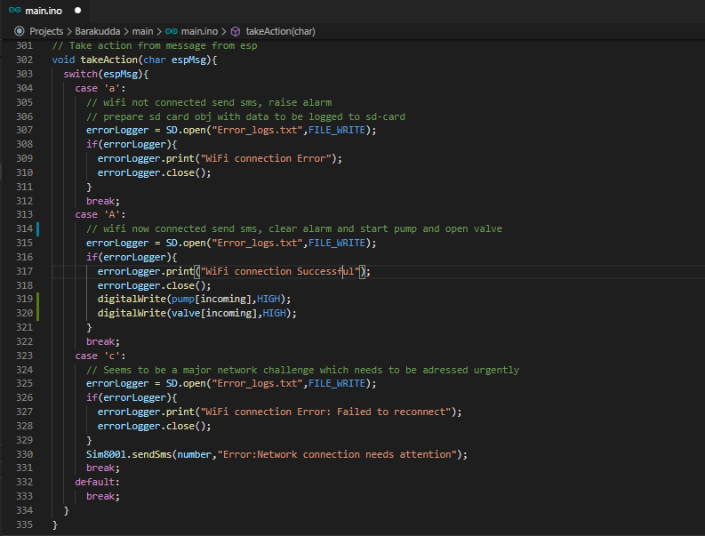

Figure 5.6 Function to take action from ESP commands

Function takeAction () receives commands from ESP module and case ‘A’ is the one responsible for opening a valve and start pump for a particular field. It also logs errors and sends SMS’s in case of errors in the field or network.

### Soil Moisture Sensor Calibration

Before using the sensor, it has to be calibrated first so that it gives the actual volumetric water content in the soil.

The sensor gives an analog output signal within the range 0 – 1023 which is the resolution of the micro controller.

The procedure is as follows:

1. Place the sensor in open air and measure the air value.
2. Place the sensor in water and measure the water value.

It is expected that the sensor produces a linear output.

The air value will be taken as the sensor low range value and water value as the upper range value. Any signal measured when the sensor is in the soil is mapped between these range values.

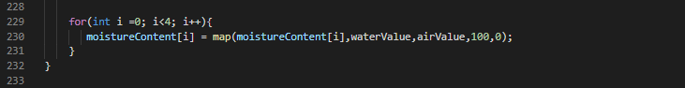

Figure 5.7 Mapping sensor signal to the actual soil moisture content

The figure above shows a routine in the program which maps the input signal to the actual moisture content in the soil.

## Hardware Controller Design

### Overview of the system

### Power supply design

Hardware components on the controller require different voltages levels to operate on

The table below shows components operating voltages

Table 5.1 Components Power Supplies

|  |  |  |
| --- | --- | --- |
| No | Device | Voltage (v) |
| 1 | WeMos Board | 5.00 dc |
| 2 | Gsm | 3.30 – 4.40 dc |
| 3 | SD card logger | 5.00 dc |
| 4 | LCD | 5.00 dc |
| 5 | All Sensors (Moisture, DHT22, LDR, Flow-Meter) | 5.00 dc |
| 6 | Pump | 220 ac |
| 7 | Valve | 24.0 dc |

From the table the voltage levels which need to be designed are

* 5.00vdc
* 3.30 vdc
* 24.00 vdc
* 220 vac will be supplied straight from mains supply.

The 3 terminal LM317 voltage regulator is used to create the variable voltages. The schematic of the power supply is shown below

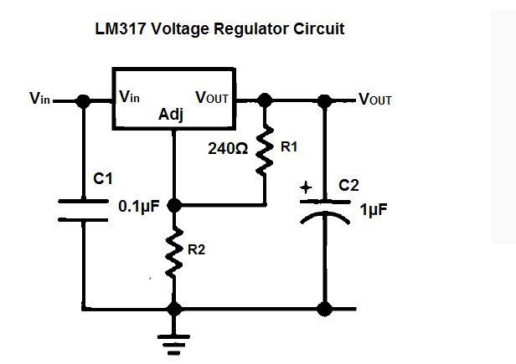

Figure 5.8 LM317 Voltage Regulator blue-print

#### Design of 5.00vdc supply

$$V_{out}=1.25\left(1 + \frac{R_{2}}{R_{1}}\right)$$

Capacitor C1 and C2 are optional they serve for the puprose of smooting noises in input and output voltage

Vout = 5.00v so we need to calculate the value of resistor R2 .

Making R2 the subject of the formular

$$R_{2}= R_{1}\left(\frac{V_{out}}{1.25}-1\right)$$

he recommended value for R1 is 240Ω

substituting into the equation we get

$$R_{2}=720 ohms$$

#### Design of 3.30 v Supply

Using same formulas from previous calculations

R1 = 240 ohms, Vout = 3.30v and the unknown is R2

substituting into the equation we get

$$R_{2}=393.6 ohms$$

#### Design of 24.00 v Supply

R1 = 240 ohms, Vout = 24.00v and the unknown is R2

substituting into the equation we get

$$R_{2}=4368 ohms$$

### Selection of Sensors

#### Moisture sensor

This is an **analog capacitive soil moisture sensor** which measures soil moisture levels by **capacitive sensing**, i.e. capacitance is varied on the basis of water content present in the soil. The capacitance is converted into voltage level basically from 1.2V to 3.0V maximum. The advantage of Capacitive Soil Moisture Sensor is that they are made of a **corrosion-resistant material** giving it a long service life.

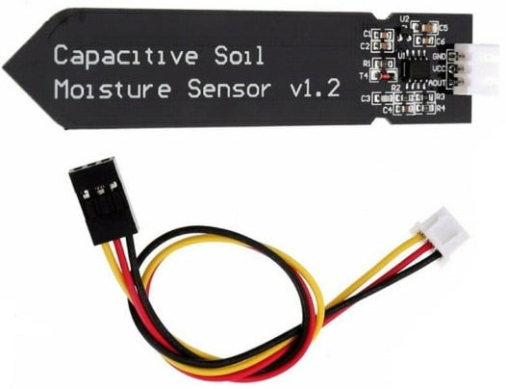

Figure 5.9 Capacitive Moisture Sensor

##### Features and Specifications

* Supports 3-Pin Sensor interface
* Analog output
* Operating Voltage: DC 3.3-5.5V
* Output Voltage: DC 0-3.0V
* Interface: PH2.0-3P
* Size: 99x16mm/3.9x0.63″

##### Sensor Schematic

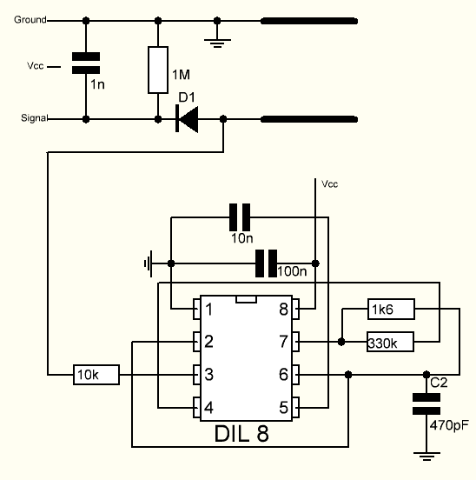

Figure 5.10 Capacitive Sensor Schematic

There is a fixed frequency oscillator that is built with a 555 Timer IC. The square wave generated is then fed to the sensor like a capacitor. To a square wave signal that capacitor, however, has a certain reactance, or for argument’s sake a resistance that forms a voltage divider with a pure ohm type resistor (the 10k one on pin 3). The greater is the soil moisture, the higher the capacitance of the sensor. Consequently, there is a smaller reactance to the square wave, thus lowering the voltage on the signal line. The voltage on the Analog signal pin can be measured by an analog pin on the Arduino which represents the humidity in the soil.

#### Temperature and Humidity

The selected temperature and humidity sensors are the DHT22 which is a basic low-cost temperature and humidity sensors. It is made up of a capacitive humidity sensor for humidity measurement and a thermistor for temperature measurement in the surrounding air. The output is a digital signal on the data pin (Nedelkolvski, 2016). The sensor is selected mainly because its measurement range falls within the parameter range of the design. The following are the technical specifications of the DHT22 temperature and humidity sensor:

* Measurement Range - -40 to 125°C and 20 to 80%
* Humidity accuracy - 2-5%
* Temperature accuracy - ±0.5°C
* Body size - 27mm x 59mm x 13.5mm and weight 2.4g
* 3 to 5V Power I/O
* 5mA max current use during conversion

Figure below shows the DHT22 temperature and humidity sensor pin layout

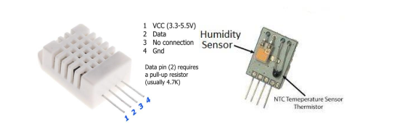

Figure 5.11 DHT22 Temperature and Humidity Sensor (Nedelkolvski, 2016*)*

## Predictive Scheduling Model

### Irrigation Depth Function

The goal of irrigation scheduling is to maintain the soil moisture content between an upper and  
lower limit. The upper limit is usually defined as the field capacity while the lower limit is a point  
above the permanent wilting point expressed a function of the management allowable depletion (*MAD*). In irrigation, it is common practice to express the amount of water retained in the plant root zone (*Wr*) as an equivalent depth of soil water (*mm* of water). This is expressed as shown in Equation below:

$W_{r}=1000θZ_{r}$

Where:

* θ is the volumetric soil moisture content
* Zr is the thickness of the root zone in meters

The water deficit at time *t* (*DPt*) is expressed as shown in equation below:

$${DP}_{t}= W_{r,FC}- W_{r,t}$$

Where:

* *Wr*,*FC* is the water depth at field capacity
* *Wr*,*t* is the water depth at time *t*

The deficit at the lower bound (*DPL*) is determined from a knowledge of the soil’s available water and the crop’s *MAD*. This is expressed as shown in Equations below:

$${DP}_{L}= W_{r,FC}- W_{r,LB}$$

With

$$W_{r,LB}=W_{r,FC}-MAD\left(W_{r,FC}-W_{r,PWP}\right)$$

Where:

* *Wr*,*LB* is the water depth at the lower bound
* *Wr*,*PWP* is the water depth at permanent wilting point.

*DPL* changes over the growth season of the crop as a result of root growth. The prediction of the soil volumetric soil moisture content at time *t* + 1 will be given by the LSTM model, making possible to calculate the deficit at time *t* + 1 (*DPt*+1). The irrigation amount is computed as the water application depth that will replenish the water deficit to the upper bound i.e.,

$$Irrigation= \left({DP}_{t+1}\right)$$

### Neural Network Model

#### Input Dense Layer

The input dense layer is the first layer of the neural network being created. According to the structure of dataset passed to the input of the neural network during the training process, we're using a dense layer as the first layer of the entire network. Dense layer, unlike the RNN layer, is a layer that is trained by using back propagation training procedure or other gradient descent methods. Dense layer normally consists of neurons, which outputs are computed by using an activation function such as either sigmoidal or hyperbolic tangent function. Each neuron in a dense layer has the number of inputs and only one output. The number of outputs in a dense layer is equal to the number of neurons. During the training process, the output values of the first dense layer are computed and passed to the next RNN - layer.

#### Reshape Layer

The re-shape layer is the layer that actually performs no output computations. Instead, the following layer is used to transform the data obtained as output of the first input dense layer into the inputs of the succeeding RNN - layer. Specifically, the re-shape layer, in this particular case, is used to re-distribute dense layer output between certain inputs of the RNN - layer.

#### Recursive Neural Network Layer

The most of the computations performed by the entire network are held in the RNN-layer. RNN - layer is actually a recurrent neural network having the number of layers, each one consisting of LSTM-cells. A recurrent neural network (RNN) is the network that uses a slightly different method of output computation. Specifically, the output of each neuron in each neural layer is passed to its input.

#### Output Dense Layer

Similar to the input layer, we're using dense layer as a final output layer for the entire network.

### Creating The Model

#### Importing Libraries

Initialization of packages.

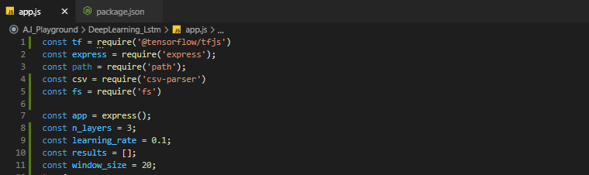

Figure 5.12 Initialization of packages

#### Model Initialization

Our model is Sequential. Each layer within a sequential model is simply stacked up by appending it to the top of stack. Each input of a new layer is interconnected with specific outputs of the previous neural layer. Line of code in the figure below show the construction of the model.

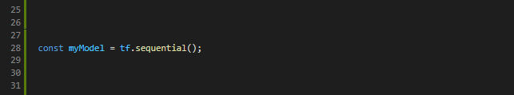

Figure 5.13 Construction of the Neural Network model

#### Creating input layer

The *input_layer_shape* and *input_layer_neurons* parameters, in this case, are used to define the input shape for the first dense layer, which is equal to the size of time window *window_size* in each sample. In turn, another parameter is used to define the number of neurons in the input layer, exactly matching the number of this layer’s outputs. Further, the output values, obtained from each neuron in the first dense layer are redistributed between specific inputs of the next neural layer.

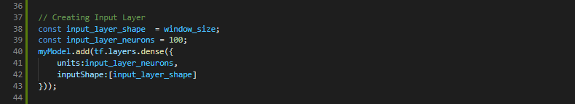

Figure 5.14 Creating input layer

#### Creating RNN Layer

Recurrent neural network (RNN) is the next layer of the model being created. To improve the quality of prediction, we’re using RNN consisting of multiple long short-term memory (LSTM) cells.

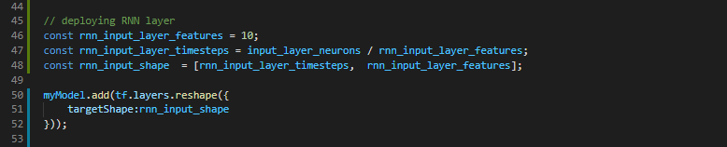

Figure 5.15 Reshaping Input Layer Output

The next step is to configure the RNN that performs the actual learning and predicted results computation. We add the number of LSTM cells to the RNN being created.

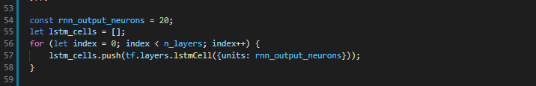

Figure 5.16 Adding LSTM Cells to the RNN

Finally, we append the RNN object to the entire model being created

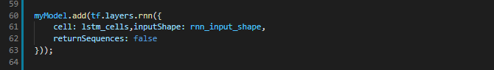

Figure 5.17 Adding RNN layer to the model

#### Output Layer

Similar to the input layer, according to the structure of model being constructed, we’re using another dense layer, responsible for computing the model outputs while performing the actual training or computing predicted values.

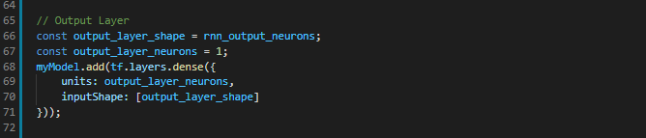

Figure 5.18 Adding Output Layer

output_layer_neurons is the argument that basically defines either the number of neurons in the output dense layer or the number of actual outputs of the entire model.

### Training Model

We have created the model that can be used to predict the moisture contents, next step is preparing it for the learning phase. This is typically done by invoking the *model.compile(…)* method. Adam-algorithm’s is being as the activation function.

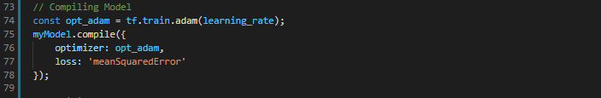

Figure 5.19 Compiling the model

We have built-up and compiled our model, next step is to perform the actual model training

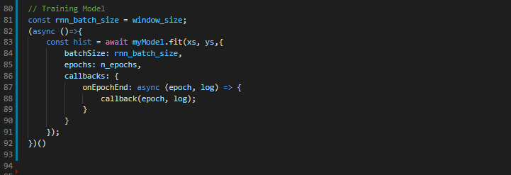

Figure 5.20 Training Model

### Predicting

After we've trained our model on the dataset of samples from the csv file containing moisture content data, now, it's time to use it for prediction purposes.

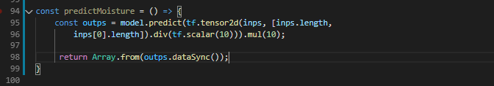

Figure 5.21 Creation of the prediction function

## Summary

The chapter focused on the system development and design of the various components that make up the system. the first part of the section looked at. The last section of the chapter focused on the design of the control system of the drying chamber which effectively controls the drying parameters.

# Chapter SIX: RESULTS

## Introduction

## Power Supply

The power supply is one of the most important part of the project. Every component on the controller depends on the smooth functionality of the power supply. Figure 6.1 shows the actual 5v supply simulated in proteus.

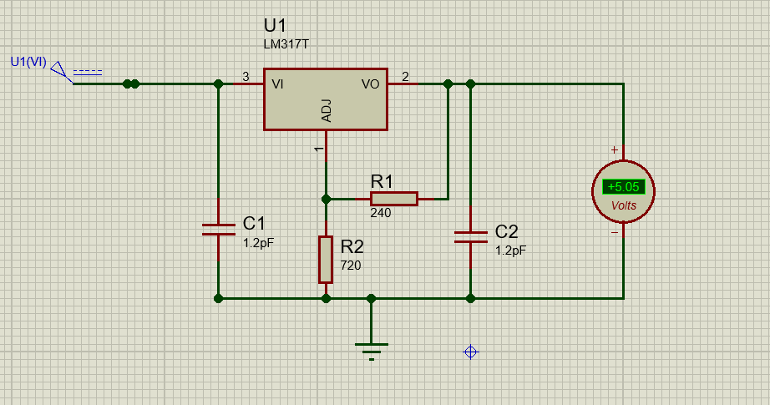

Figure 6.1 5.05vdc power supply

The figure below shows the 3.33vdc power supply

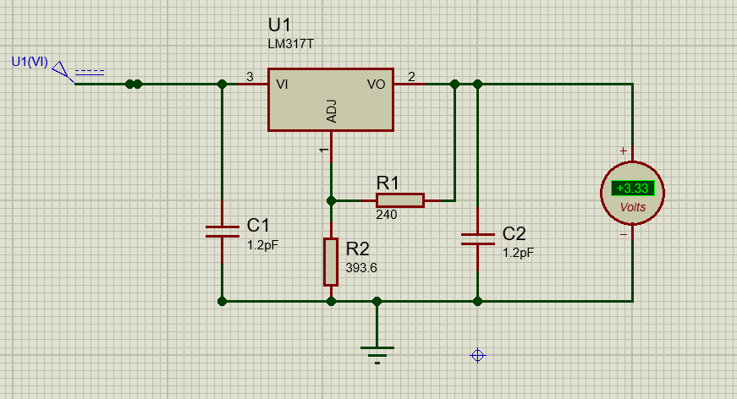

Figure 6.2 3.33vdc power supply

The figure below shows the 24v power supply. Due to limitation in the smoothing of the circuit using the LM317 regulator. There was a drop of 2.0 volts. For the sake of our prototype the drop won’t affect the any functionality.

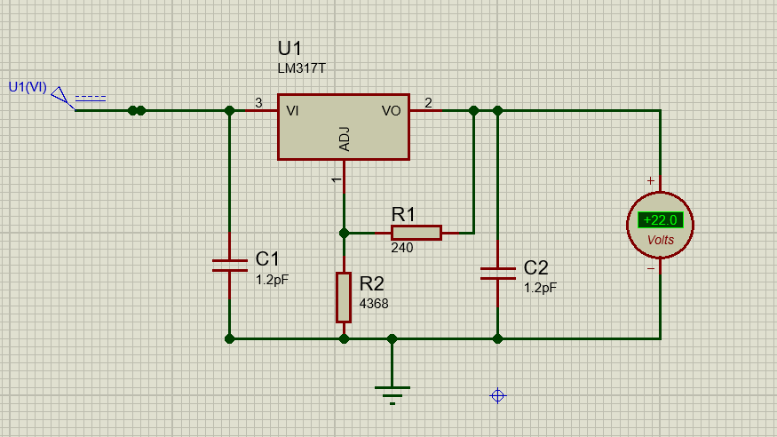

Figure 6.3 22.0vdc Power Supply

## Operation of The Controller

The prototype of the irrigation controller was developed to represent the actual layout of the physical system using off shelf components and the respective connections between the major constituent components namely ATX power supply, WeMos Microcontroller, relay mechanism and the datalogger.

## Monitoring Web Application

## Moisture Prediction

## Economic Analysis

This section involves the costing of the project. It is carried out to evaluate the costs associated with implementing the project so as to enable the evaluation of the financial feasibility of  
implementing the project.

### Bill of Materials (BOM)

The table below shows the description of the items that make up the automatic solar multifruit  
drying system, the respective unit prices of each item, the quantities required as well as the  
total price of each item. All prices were extracted from AliExpress (2020) for estimation purposes.

|  |  |  |  |
| --- | --- | --- | --- |
| Description | Unit Price (usd) | Quantity | Total Price |
| WeMos Mega2560 | 16.00 | 1 | 16.00 |
| Relay switch | 5.00 | 9 | 45.00 |
| ATX power supply | 20.00 | 1 | 20 |
| 20x4 LCD | 15.00 | 1 | 15.00 |
| Casing | 20.00 | 1 | 15.00 |
| DHT22 | 6.00 | 1 | 6.00 |
| 220-240v breaker | 5.00 | 1 | 5.00 |
| Cloud Server (Heroku) | 5.00 | - | 5.00 |
| Connecting Wires | 5.00 | - | 5.00 |
| Moisture Sensors | 3.00 | 5.00 | 12.00 |
| **Total** | | | **144.00** |

### Labour Costs

This section involves the analysis of all the labour requirements that are encountered during  
the implementation of the project. For a comprehensive financial analysis of the project, the  
labour requirements should be included as they constitute a considerable amount of cost of the  
project.

Table 6.1 labour Costs

|  |  |  |  |  |  |
| --- | --- | --- | --- | --- | --- |
| Personnel Type | Number | Nature of Task | HourlyRate (usd/hr) | Duration ofTask (hrs) | Total Cost  (USD) |
| Electronic Technician | 1 | Programming and connecting the control System | 10.00 | 40 | 400.00 |
| Full Stack Web Developer | 1 | Development of the Web App | 15.00 | 40 | 600.00 |
| **Estimated Labour Costs** | | | | | **1000.00** |

### Total Cost Estimation

Assuming total overhead costs to amount to **$ 600**, the total cost of the project is therefore:

Total Material Costs **$144.00**

Total Labour Costs $**1000.00**

Overhead Costs **$600**

Total Capital Investment Costs **$ 1744.00**

### Cost Benefit Analysis

It is a procedure used to compare the costs and benefits associated with a project and how it  
will perform financially over its expected time of use. It evaluates the desirability of the project  
by weighing the benefits against the cost by effectively taking note of all the factors affecting  
the project.

The following table below summarizes the associated costs and benefits associated with the project

Table 6.2 Cost Benefit Analysis

|  |  |
| --- | --- |
| **Costs** | **Benefits** |
| Initial capital investment costs associated  with purchasing the controller equipment | Improved profit margins due to value addition  of the farm outputs |
| Direct labour costs associated with the  system development | Reduced crop death due to over and under irrigation i.e. improved crop health |
| Maintenance and operational expenses  associated with the project | Improved earnings to farmers as the system  can lead to the generation of extra income through higher yields, quality produce and cutting irrigation costs |
|  | Creation of employment to the local  community (Maintenance of the controllers) |

## Summary

This chapter presented the results of the project functionality to meet the irrigation scheduling. The economic analysis was done out to investigate the financial feasibility of the project. A prototype has been built to tests the functionality of the system in meeting the design objectives.

# Chapter SEVEN RECOMMENDATIONS AND CONCLUSION

## Introduction

The chapter gives an outline of the conclusion, recommendations and future work of the smart irrigation controller. It presents the conclusions of the work that was carried out during the implementation of the project so as to meet the previously mentioned design objectives. The recommendations highlight the major areas of possible improvement. The future work to be carried out by upcoming researchers is also highlighted.

## Overview

## Recommendations for Future Work

The following recommendations should be considered for further development of the system

* Periodic Maintenance

Periodic maintenance of the controller would lead to the optimal efficiency as well as maintaining the quality of the crops.

* Development of a cross platform mobile application

This will give operator even more control of the farming activities remotely as the application can be accessed via a mobile application.

* Controllino PLC

This is a low-cost PLC for industrial applications which can integrate well will Arduino platform. Inclusion of this controller would increase the robustness of the system

* Data Sharing

Create a platform where many farms are connected together sharing various data and using artificial intelligence to optimize farming activities.

## Challenges faced

* Training data for the soil moisture was limited to being hourly sequenced because of lack of time to collect data for a long period.
* Procurement of components from China takes 2 months and tracking of the components on sellers’ websites is difficult because the components are too small.

## Summary

The above project was mainly focused with the design of a smart irrigation controller with soil moisture capabilities.

# REFERENCES

Victor, D.G., Morgan, M.G., Apt, F. and Steinbruner, J., 2009. The geoengineering option-a last resort against global warming.

Smith, R., 2011. *Review of precision irrigation technologies and their applications*. University of Southern Queensland.

Adeyemi, O., Grove, I., Peets, S., Domun, Y. and Norton, T., 2018. Dynamic neural network modelling of soil moisture content for predictive irrigation scheduling. *Sensors*, *18*(10)

Baiphethi, M.N. and Jacobs, P.T., 2009. The contribution of subsistence farming to food security in South Africa. *Agrekon*, *48*(4)

<https://www.krcu.org/post/aberrant-weather-affects-crops>

<http://www.columbia.edu/~tmt2120/impacts%20to%20life%20in%20the%20region.htm>

Awati, J.S. and Patil, V.S., 2012. Automatic Irrigation Control by using wireless sensor networks. *Journal of Exclusive Management Science*

Heath, R.C., 1998. *Basic ground-water hydrology* (Vol. 2220). US Department of the Interior, US Geological Survey.

Mmolawa., 2000. Root zone solute dynamics under drip irrigation: A review. *Plant and soil*, *222*(1-2), pp.163-190.

Christiansen, J.E., 2001. *Irrigation by sprinkling* (Vol. 4). Berkeley: University of California.

Evans, R.G., Wu, I.P. and Smajstrala, A.G., 2007. . Microirrigation Systems. In *Design and Operation of Farm Irrigation Systems, 2nd Edition* (pp. 632-683). American Society of Agricultural and Biological Engineers.

Clark, A. ed., 2008. *Managing cover crops profitably*. Diane Publishing.

Pair, C.H., 1970. *Sprinkler irrigation* (No. 476). Department of Agriculture, Agricultural Research Service.

Babiker, W.E.E., 2019. *Design and simulation of a control system for a center pivot irrigation device* (Doctoral dissertation, Sudan University of Science and Technology).

Fipps, G., 2003. Irrigation water quality standards and salinity management strategies. *Texas FARMER Collection*.

Burns, R.E., 1993. Irrigated rice culture in monsoon Asia: The search for an effective water control technology. *World Development*, *21*(5), pp.771-789.

Roy, A.K., Seshadri, S., Ghotge, S., Gupta, A. and Deshpande, A., 1982. Planning the Environment. *Anuppur: Vidushak Karkhand*.

Arnold, R.T., Troost, C. and Berger, T., 2015. Quantifying the economic importance of irrigation water reuse in a C hilean watershed using an integrated agent‐based model. *Water Resources Research*, *51*(1).

Laraus, J., 2004. The problems of sustainable water use in the Mediterranean and research requirements for agriculture. *Annals of Applied Biology*, *144*(3).

Bot, A. and Benites, J., 2005. *The importance of soil organic matter: Key to drought-resistant soil and sustained food production* (No. 80). Food & Agriculture Org..

Hillel, D., 2003. *Introduction to environmental soil physics*. Elsevier.

Bell, F.G., 2013. *Engineering properties of soils and rocks*. Elsevier.

Gaushell, D.J. and Darlington, H.T., 1987. Supervisory control and data acquisition. *Proceedings of the IEEE*, *75*(12).

Stouffer, K.A., Falco, J.A. and Scarfone, K.A., 2011. Sp 800-82. guide to industrial control systems (ics) security: Supervisory control and data acquisition (scada) systems, distributed control systems (dcs), and other control system configurations such as programmable logic controllers (plc).

Schulz, G., 2011. *Cloud and virtual data storage networking*. CRC Press.

Ben, 2012. Sparkfun.com. [Online] Available at: What is an Arduino%20 -learn.sparkfun.com.htm

Miller, M., 2008. *Cloud computing: Web-based applications that change the way you work and collaborate online*. Que publishing.

Rayes, A. and Salam, S., 2017. Internet of things from hype to reality. *The Road to Digitization; River Publisher Series in Communications; Springer: Basel, Switzerland*, *49*.

Parab, J., Shelake, V.G., Kamat, R.K. and Naik, G.M., 2007. *Exploring C for microcontrollers: A hands on approach*. Springer Science & Business Media.

Barrett, S.F., 2013. Arduino microcontroller processing for everyone!. *Synthesis Lectures on Digital Circuits and Systems*, *8*(4).

Una, A.Z., design of a drone based measurement system for gsm signals.

Pharaskhanewala, P., Rehal, M.K., Wagh, A. and Malpe, K., 2009. Wireless Notice-Board Using Node MCU.

Ibrahim, D., 2010. *SD card projects using the PIC microcontroller*. Newnes.

Ahuja, D. and Parande, D., 2012. Optical sensors and their applications. *Journal of Scientific Research and Reviews*, *1*(5).

Kelleners, T.J., Soppe, R.W.O., Robinson, D.A., Schaap, M.G., Ayars, J.E. and Skaggs, T.H., 2004. Calibration of capacitance probe sensors using electric circuit theory. *Soil Science Society of America Journal*, *68*(2).

Robinson, D.A., Jones, S.B., Wraith, J.M., Or, D. and Friedman, S.P., 2003. A review of advances in dielectric and electrical conductivity measurement in soils using time domain reflectometry. *Vadose Zone Journal*, *2*(4).

Pardossi, A., Incrocci, L., Incrocci, G., Malorgio, F., Battista, P., Bacci, L., Rapi, B., Marzialetti, P., Hemming, J. and Balendonck, J., 2009. Root zone sensors for irrigation management in intensive agriculture. *Sensors*, *9*(4).